EEG based control with IOT integration for next-generation smart wheelchair



A BS Final Year Project by
Talal Shaheen
1082/FET/BSEE/F22

Jawad Faisal
1108/FET/BSEE/F22

Zaki-Ur-Rehman
1112/FET/BSEE/F22

Supervised by
Dr. Abdul Basit

Department of Electrical and Computer Engineering
Faculty of Engineering and Technology
International Islamic University, Islamabad

May, 2026

Certificate of Approval
It is certified that we have checked the project presented and demonstrated by TalalShaheen 1082-FET/BSEE/F22, Jawad Faisal 1108-FET/BSEE/F22, Zaki-Ur-Rehman 1112-FET/BSEE/F22 and approved it.

External Examiner  Name here…  Designation | Internal Examiner  Name here…  Designation

Supervisor Co-supervisor
Dr. Abdul Basit Engr. Your Co-supervisor (if any)
Associate Professor Designation



In the name of Allah (SWT), the most beneficent and the most merciful

A BS Final Year Project submitted to the
Department of Electrical and Computer Engineering
International Islamic University, Islamabad
In partial fulfillment of the requirements
For the award of the degree of
Bachelor of Science in Electrical Engineering

Declaration
We hereby declare that this work, neither as a whole nor as a part thereof has been copied out from any source. No portion of the work presented in this report has been submitted in support of any application for any other degree or qualification of this or any other university or institute of learning. We further declare that the referred text is properly cited in the references.

Talal Shaheen
1082-FET/BSEE/F22

Jawad Faisal
1108-FET/BSEE/F22

Zaki-Ur-Rehman
1112-FET/BSEE/F22

Acknowledgments
This BS thesis in Electrical Engineering has been conducted at Department of Electrical and Computer Engineering, Faculty of Engineering and Technology, International Islamic University, as part of the degree program. We would like to thank Dr. Abdul Basit for providing us an opportunity to work on this project, under his supervision and guidance throughout the project. We would also like to thank Engr. Asad Ehsan for his help, efforts and dedicated support throughout the project. Further we are particularly thankful to Almighty Allah and grateful to our parents, brothers and sisters who always supported and encouraged us during our project and studies at IIUI.

Talal Shaheen
Jawad Faisal
Zaki-Ur-Rehman

Project Title: | EEG based control with IOT integration for next-generation smart wheelchair
Undertaken By: | Talal Shaheen (1082-FET/BSEE/F22)  Jawad Faisal (1108-FET/BSEE/F22)  Zaki-Ur-Rehman (1112-FET/BSEE/F22)
Supervised By:  Co-Supervised By: | Dr. Abdul Basit  Associate Professor  Supervised By: Engr. Your co-supervisor (if any)  Lab Engineer
Date Started: | September, 2025
Date Completed: | june, 2026
Tools Used:
- Arduino IDE
- Raspberry Pi OS
- Python 3.x
- PyTorch
- Scikit-learn
- NumPy
- SciPy
- Pandas / OpenPyXL
- VS Code
- Proteus

Abstract
Limited mobility remains one of the most debilitating consequences of neurological disorders, spinal cord injuries, and progressive muscular diseases. For individuals who have lost voluntary motor control, traditional wheelchair interfaces such as joysticks and manual controls are not viable. This project presents an intelligent wheelchair control system driven entirely by EEG-captured eye blink signals, using the iWorks Brain Sensor to acquire brain activity across four frontal channels at 100 Hz. Signals are transmitted to a Raspberry Pi 4 where band-pass filtering, artifact suppression, and 2-second windowing are applied before classification. A CNN-LSTM-Attention deep learning model maps detected blink patterns to movement commands — single blink for forward, double blink for backward, and triple blink for stop — achieving 100% test accuracy on 1,225 labelled samples with an average inference time of 20.02 milliseconds. Safety is provided through an Arduino microcontroller reading three sensors — an HC-SR04 ultrasonic sensor for obstacle detection, an MPU-6050 gyroscope for tilt monitoring, and a MLX90614 temperature sensor for patient health awareness — all communicating with the Raspberry Pi via USB serial. The system operates entirely on embedded hardware with no cloud dependency, offering a low-cost, portable, and practically deployable assistive technology for individuals with severe physical disabilities.

Table of Contents
Chapter 1 1
Introduction 1
1.1 Motivation 2
1.2 Project Overview 3
1.2.1 System Components 3
1.3 Problem Statement 4
1.4 Project Objectives 5
1.5 Brief Project Methodology 6
1.6 Report Outline 8
Chapter 2 10
Literature Review 10
2.1 Background of Project 11
2.2 Related Work/Projects 13
2.3 Project Contribution 16
2.4 Summary 17
Chapter 3 18
System Design and Implementation Details/Design Procedures 18
3.1 System Design 18
3.1.1 System Architecture 18
3.1.2 Requirements/Requirements Analysis 19
3.2 Methodological/Implementation/Experimental Details 20
3.2.1 Hardware Setup 20
3.2.2 Hardware Details 21
3.2.3 Software/Tools 22
3.3 Algorithms/Simulation Details 23
3.4 System Integration and Communication 26
3.5 System Constraints and Limitations 28
Chapter 4 31
Testing and Validation 31
4.1 Testing 31
4.1.1 Prototypes 32
4.1.2 Test Cases 33
4.2 Results/Output/Statistics 34
4.2.1 Completion 34
4.2.2 Accuracy 35
4.2.3 Correctness 41
Chapter 5 43
Conclusion and Future Recommendations 43
5.1 Conclusion 43
5.2 Future Recommendations 45
References 50
Annexure ‘A’ 52
Pseudocode — EEG Blink DetectionSystem 52

List of Figures
Figure 1.1: Proposed EEG-driven blink-control system for assistive mobility. 3

Figure 1.2: System concept of the proposed EEG-based smart wheelchair. 4

Figure 1.3: Project methodology flowchart 8

Figure 2.1: CNN-LSTM-Attention model architecture for EEG blink classification 13

Figure 3.1: System Architecture Block Diagram 19

Figure 3.2: ML pipeline flowchart showing the complete step-by-step algorithm 26

Figure 4.1: Photograph of the assembled EEG-based smart wheelchair prototype 33

Figure 4.2: Training and validation accuracy and loss curves 36

Figure 4.3: Confusion matrix heatmap 38

Figure 4.4: ROC curves per command class. 39

Figure 4.5: Sample EEG blink predictions showing model output vs actual labels. 41

Figure 5.1: Future work roadmap for the EEG-based smart wheelchair system across three
development phases. 45

Figure 5.2: Progression of system capabilities across near-term, mid-term, and long-term
development phases. 49

List of Tables
Table 2.1: Comparative analysis of related EEG-based wheelchair systems 14

Table 3.1: Hardware requirements 20

Table 3.2: Hardware component specifications 22

Table 3.3: Software tools and libraries 22

Table 3.4: Blink pattern to wheelchair command mapping 24

Table 3.5: Key algorithm characteristics 25

Table 4.1: System test cases 33

Table 4.2: Project objectives completion status 34

Table 4.3: Model Performance Metrics 35

Table 4.4: Per-Class Classification Performance 36

Table 4.5: Ablation Study — Model Variant Comparison 39

Table 4.6: Accuracy comparison with related systems 40

Table 4.7: End-to-end command correctness 42

Table 4.8: Safety sensor correctness 42

List of Abbreviations

Abbreviation | Full form
EEG | Electroencephalography
BCI | Brain-Computer Interface
AI | Artificial Intelligence
ML | Machine Learning
CNN | Convolutional Neural Network
LSTM | Long Short-Term Memory
MLP | Multi-Layer Perceptron
IoT | Internet of Things
GPIO | General Purpose Input Output
PWM | Pulse Width Modulation
I2C | Inter-Integrated Circuit
USB | Universal Serial Bus
DC | Direct Current
FFT | Fast Fourier Transform
ICA | Independent Component Analysis
ROC | Receiver Operating Characteristic
BMS | Battery Management System
Hz | Hertz
RAM | Random Access Memory
ARM | Advanced RISC Machine
PyTorch | Python-based deep learning framework
API | Application Programming Interface
IDE | Integrated Development Environment

Chapter 1

Introduction
In recent years, advancements in biomedical engineering and artificial intelligence have enabled the development of intelligent assistive systems for individuals with severe physical disabilities. One of the most promising technologies in this domain is the Brain-Computer Interface (BCI), which allows direct communication between the human brain and external devices without requiring muscular activity [2].
Electroencephalography (EEG) is a widely used non-invasive technique for acquiring brain signals [7]. These signals contain valuable information about human intentions and physiological activities, including eye blinks. Eye blinks produce distinct patterns in EEG signals, making them suitable for control applications in assistive technologies [11].
This project presents the design and implementation of an EEG-based smart wheelchair system that utilizes eye blink detection combined with machine learning techniques. Unlike traditional systems that rely on manual or joystick-based control, this system interprets brain signals to generate movement commands. The integration of artificial intelligence enables accurate classification of eye blink patterns, improving reliability in real-world environments.
A key feature of this project is the deployment of the trained machine learning model on a Raspberry Pi, enabling real-time processing of EEG signals. The system detects eye blinks, and translates them into control commands such as forward, backward, and stop movement of the wheelchair.
In addition to control functionality, the system incorporates safety mechanisms using sensors such as gyroscopes for stability monitoring and obstacle detection sensors for collision avoidance. These features ensure that the wheelchair operates safely and efficiently in dynamic environments.
Overall, this project demonstrates a cost-effective, intelligent, and user-friendly mobility solution that enhances independence for physically disabled individuals by combining EEG technology and machine learning.

Motivation
Mobility impairment is a significant challenge faced by individuals suffering from severe neurological disorders, paralysis, or other physical disabilities. Such individuals often lack the motor control required to operate conventional mobility aids. Traditional wheelchairs, whether manual or joystick-based, rely heavily on physical input, making them unsuitable for users with limited or no limb movement. As a result, these individuals become highly dependent on caregivers, which negatively impacts their independence and overall quality of life.
Recent advancements in Brain-Computer Interface (BCI) technology and artificial intelligence have opened new possibilities for assistive systems that can interpret human intentions directly from brain activity. Electroencephalography (EEG), a non-invasive and cost-effective technique, enables the acquisition of brain signals in real time. Among the various EEG signal patterns, eye blinks are particularly prominent due to their high amplitude and ease of detection, making them a reliable control mechanism.
Despite these advancements, many existing EEG-based wheelchair systems suffer from limitations such as low accuracy, high computational complexity, and lack of real-time performance [6][7]. Additionally, systems based on simple thresholding techniques are often unreliable in noisy environments and may fail to provide consistent results [6][7].
This project is therefore motivated by the need to develop an intelligent, real-time, and reliable smart wheelchair system that leverages EEG-based eye blink detection combined with machine learning techniques. By incorporating a trained AI model deployed on an embedded platform, the system aims to achieve accurate signal classification and responsive control. Furthermore, the integration of safety features such as obstacle detection and stability monitoring enhances the practicality and reliability of the system in real-world scenarios.
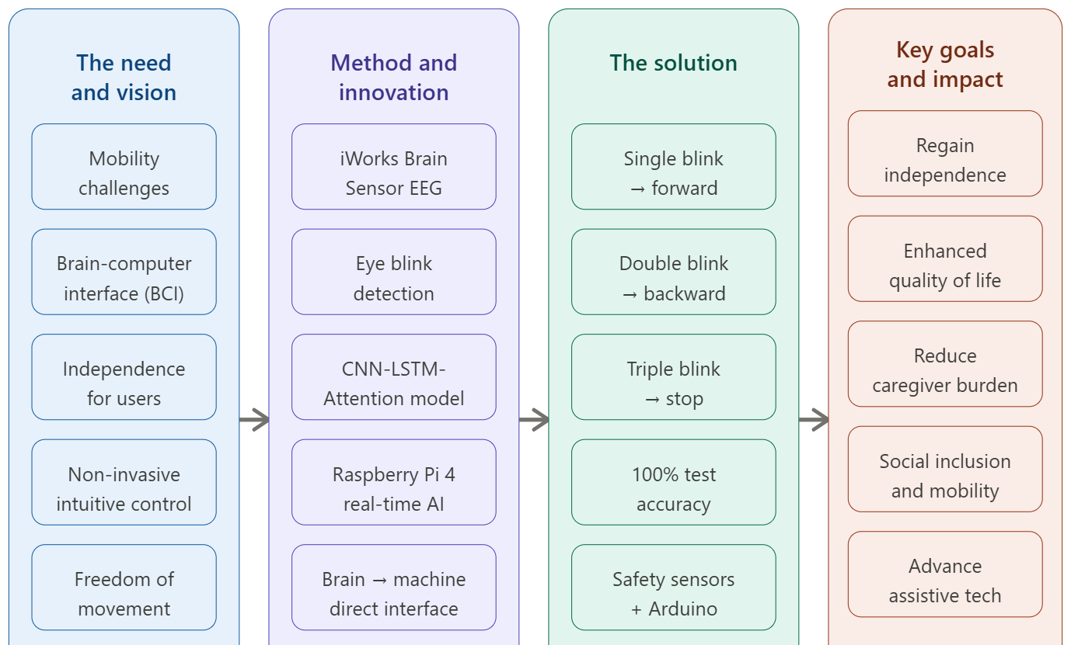

Figure 1.1: Proposed EEG-driven blink-control system for assistive mobility.

Project Overview
The proposed system is an AI-based EEG smart wheelchair that enables users to control movement using eye blinks. The system operates in two major phases:
1. Data Acquisition and Model Training
- EEG signals are collected using an EEG headset
- A dataset is created for different blink patterns
- A machine learning model is trained to classify these patterns
2. Real-Time Implementation
- The trained model is deployed on a Raspberry Pi
- Real-time EEG signals are acquired
- The AI model processes incoming data
- Recognized commands are sent to the motor control system
- The wheelchair responds to commands such as forward, backward, and stop. In addition, safety features like obstacle detection and stability monitoring are integrated using sensors.

1.2.1 System Components
The system consists of the following major components:
- EEG headset for brain signal acquisition
- Raspberry Pi for real-time processing and AI inference
- Machine learning model for blink classification
- Arduino for sensor interfacing and communication with Raspberry Pi for control and safety.
- Motor drivers for controlling high-power motors
- DC motors for wheelchair movement
- Sensors (e.g., gyroscope, obstacle, temperature sensors,) for safety and monitoring.
- Battery power supply system
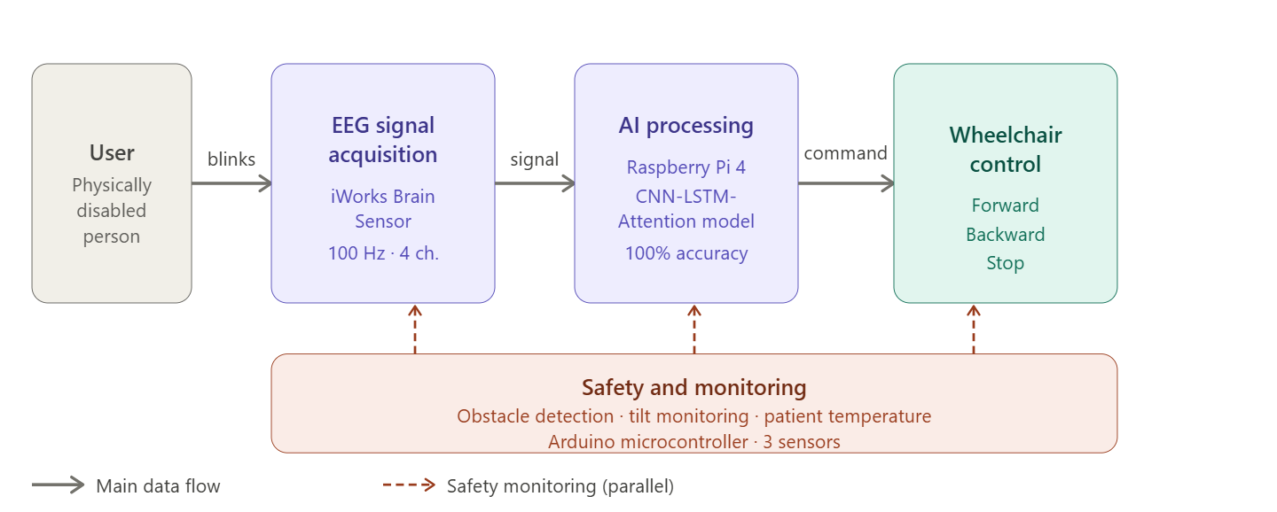

Figure 1.2: System concept of the proposed EEG-based smart wheelchair.

Problem Statement
Existing mobility solutions for individuals with severe physical disabilities are largely dependent on physical input mechanisms such as joysticks, switches, and manual controls [6][7]. These methods are entirely unsuitable for users with little or no voluntary motor control, severely limiting their ability to operate assistive devices independently. As a result, many such individuals remain highly and continuously dependent on caregivers for even basic mobility needs, significantly reducing their quality of life and personal autonomy.
Although recent advancements have introduced smart wheelchair systems based on brain-computer interface technology and EEG signals, these systems still face several critical challenges that prevent widespread real-world deployment [2][4]:
- High cost and system complexity, making them largely inaccessible for everyday use particularly in developing countries
- Low accuracy in EEG signal interpretation, especially in the presence of noise, motion artifacts, and electrode variability across users
- Limited real-time processing capability on embedded hardware, leading to delayed and unreliable command responses
- Lack of robust and multi-layered safety mechanisms, significantly increasing the risk of accidents during unsupervised operation
Furthermore, many existing EEG-based systems rely heavily on simple threshold-based techniques for detecting eye blinks or other brain signals [6][7]. These methods are highly sensitive to noise, inter-user variability, and changing environmental conditions, frequently resulting in unreliable performance, false triggering, and missed commands. More recently, machine learning approaches have been explored to overcome these limitations, yet many proposed systems have only been evaluated in controlled laboratory settings and have not been validated on low-cost embedded platforms suitable for real-world deployment [3][5].
In addition, the absence of intelligent decision-making algorithms and integrated health monitoring in many existing systems severely limits their adaptability, safety, and scalability for practical assistive applications [10]. Most reviewed systems address either control or safety in isolation — very few integrate both within a single affordable embedded solution [1][11].
Therefore, there is a clear and pressing need to develop an intelligent, machine learning-based EEG smart wheelchair system that can accurately classify eye blink patterns in real time, operate efficiently on low-cost embedded hardware without cloud dependency, and ensure comprehensive user safety through the integration of advanced multi-sensor mechanisms. The proposed system directly addresses these limitations by combining EEG signal processing, a CNN-LSTM-Attention deep learning architecture, and an Arduino-managed safety sensor network to provide a reliable, affordable, and user-friendly mobility solution for individuals with severe physical disabilities [1][2][3].

Project Objectives
The primary objective of this project is to design and develop an intelligent EEG-based smart wheelchair system that enables users to control movement using eye blink signals. To achieve this, the following specific objectives are defined:
- To acquire EEG signals using a non-invasive EEG headset and develop a structured dataset of eye blink patterns
- To perform signal preprocessing and feature extraction to enhance the quality and reliability of EEG data
- To design, train, and evaluate a machine learning model for accurate classification of eye blink signals
- To deploy the trained model on a Raspberry Pi for real-time processing and decision-making
- To develop a control mechanism that converts classified signals into wheelchair movement commands (forward, backward, and stop)
- To interface motor drivers and DC motors for smooth and efficient wheelchair movement
- To integrate safety and monitoring features, including:
- Obstacle detection for collision avoidance
- Gyroscope sensor for stability and tilt detection
- Temperature sensor for monitoring user safety
- To develop a system that is cost-effective, reliable, and user-friendly for practical assistive applications

Brief Project Methodology
The proposed project follows a systematic and structured methodology consisting of multiple stages, starting from data acquisition to real-time implementation and system validation.
1. Signal Acquisition
EEG signals are acquired using a non-invasive wearable EEG headset placed on the user’s scalp. The headset captures brain activity, including eye blink signals, which produce distinct patterns in the EEG waveform.
- Eye blink data is recorded under controlled conditions
- Multiple trials are conducted to ensure dataset diversity
- Signals are labeled according to different blink patterns
- This stage forms the foundation for building a reliable dataset for model training.
2. Data Preprocessing
The acquired EEG signals are often contaminated with noise and artifacts caused by muscle movement, environmental interference, and sensor limitations. Therefore, preprocessing is essential.
- Noise filtering techniques (e.g., band-pass filtering) are applied
- Artifacts are removed to improve signal clarity
- Signal normalization is performed
- Relevant features are extracted from the EEG signals
- This step improves the quality of input data and enhances model performance.
3. Model Training
A machine learning model is developed to classify eye blink patterns based on the processed EEG data.The prepared dataset is divided into training and testing sets.
- A suitable model such as CNN-LSTM-Attention is selected based on its proven effectiveness in capturing spatial and temporal EEG features [1][3]
- The model is trained to recognize different blink patterns
- Performance metrics such as accuracy and loss are evaluated
- This stage ensures that the system can accurately interpret user intentions.
4. Model Deployment
After successful training, the model is deployed on an embedded platform.
- The trained model is integrated into a Raspberry Pi
- The system is configured for real-time signal processing
- This enables on-device inference without reliance on external computing systems.
5. Real-Time Control System
In real-time operation, the system continuously processes incoming EEG signals.
- EEG data is acquired and preprocessed in real time
- The trained model classifies the signal
- Detected blink patterns are mapped to control commands
- Commands are transmitted to the motor driver
- The wheelchair performs actions such as:
- Forward movement
- Backward movement
- Stop function
6. Safety and Monitoring Integration
To enhance reliability and user safety, multiple sensors are integrated into the system:
- Gyroscope Sensor: Detects tilt and potential fall conditions
- Obstacle Detection Sensors: Prevent collisions by detecting nearby objects
- Temperature Sensor: Monitors user safety
These safety features ensure stable operation and reduce the risk of accidents during real-world use.
7. Testing and Validation
The final system is tested to evaluate its performance under different conditions.
- Accuracy Testing: Measures correctness of blink classification
- Response Time Analysis: Evaluates system latency
- Real-Time Performance: Assesses continuous operation capability
- Safety Testing: Verifies sensor-based protections
The results are analyzed to ensure the system meets reliability and usability requirements.
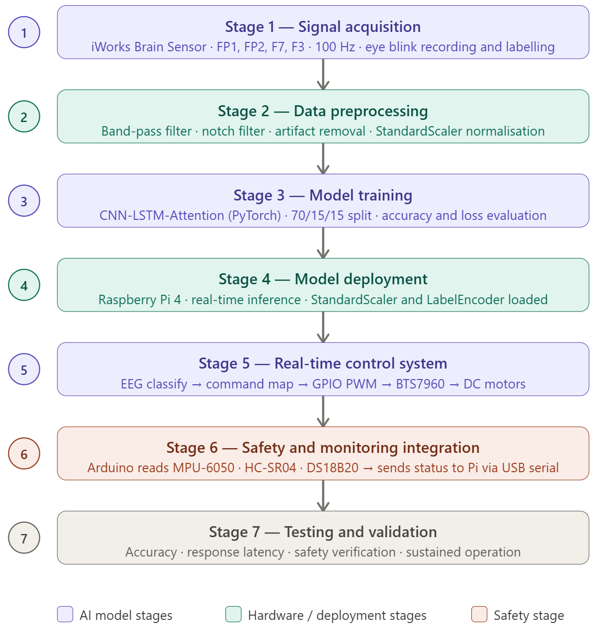

Figure 1.3: Project methodology flowchart

Report Outline
The remainder of this report is organized as follows:
Chapter 2: Literature Review
This chapter provides the theoretical background of the project, including an introduction to EEG signals, brain-computer interface (BCI) systems, and smart wheelchair technologies. It also reviews existing research and related projects in the field, highlighting their methodologies and limitations. Furthermore, the contribution of the proposed system is discussed, followed by a summary of the chapter.
Chapter 3: System Design and Implementation Details
This chapter presents the overall system architecture and design of the proposed EEG-based smart wheelchair. It includes system flow diagrams, hardware and software requirements, and detailed implementation procedures. The chapter also describes hardware setup, component specifications, software tools, and the algorithms used for signal processing and machine learning-based classification.
Chapter 4: Testing and Validation/Discussion
This chapter focuses on the testing and evaluation of the developed system. It includes prototype development, test cases, and performance analysis. The results are presented in terms of system accuracy, response time, and correctness, followed by a discussion of the system’s performance.
Chapter 5: Conclusion and Future Recommendations
This chapter summarizes the overall outcomes and achievements of the project. It highlights the effectiveness of the proposed system and discusses its limitations. Additionally, it provides recommendations for future improvements and potential enhancements.
References
This section lists all the research papers, articles, and sources referred to during the project in a standard citation format.
Annexure ‘A’
This section includes supplementary material such as pseudocode or any supporting documents relevant to the project.

Chapter 2

Literature Review
This chapter presents a comprehensive and critical review of existing research related to EEG-based smart wheelchairs and Brain-Computer Interface (BCI) systems. EEG technology has emerged as a promising solution for assisting individuals with severe physical disabilities by enabling direct communication between the human brain and external devices [2][7]. In this context, numerous researchers have explored the use of EEG signals for controlling assistive devices such as wheelchairs, aiming to improve user independence and quality of life [10][11].
The chapter analyses a wide range of previously developed methodologies, including signal acquisition techniques, preprocessing methods, feature extraction approaches, and classification models used for interpreting EEG signals. Special emphasis is placed on understanding how different systems translate brain signals or eye blink patterns into control commands for wheelchair navigation. Both traditional approaches such as threshold-based detection [6][7] and modern techniques involving machine learning and deep learning are examined [1][3][4].
Furthermore, this chapter evaluates the strengths and limitations of existing systems in terms of key performance factors such as accuracy, cost, computational complexity, and real-time implementation capability. Many existing solutions suffer from challenges such as sensitivity to noise, low classification accuracy, high system cost, and lack of robustness in real-world environments [5][8][9]. These limitations highlight the need for more efficient and practical solutions that can operate reliably outside controlled laboratory conditions.
In addition, a comparative analysis of various machine learning techniques used for EEG signal classification is presented. Methods such as Convolutional Neural Networks (CNN), Long Short-Term Memory (LSTM) networks, and hybrid models are discussed in terms of their effectiveness in capturing temporal and spatial features of EEG data [1][3]. Recent advancements in artificial intelligence have significantly improved the reliability of EEG-based systems, making real-time processing on embedded platforms increasingly feasible [2][4].
Research gaps
- Lack of real-time embedded implementation in most existing EEG-based wheelchair systems.
- Limited ability to maintain high classification accuracy in noisy, real-world environments.
- Many systems have high hardware and implementation costs, making them impractical for widespread use.
- Absence of efficient integration of multiple processing stages (acquisition → preprocessing → classification → control) in a single system.
- Limited use of hybrid deep learning models (e.g., CNN + LSTM + Attention) in a unified framework.
- Inadequate safety mechanisms, such as obstacle detection and emergency control systems.
- Limited focus on user-friendly and practical deployment for daily use.

Background of Project
Electroencephalography (EEG) is a non-invasive technique used to measure the electrical activity of the brain through electrodes placed on the scalp. These electrical signals represent the collective activity of neurons and are widely used in medical diagnosis, neuroscience research, and assistive technologies [7]. EEG signals are characterised by different frequency bands — alpha (8–13 Hz), beta (13–30 Hz), theta (4–8 Hz), and delta (0.5–4 Hz) — each corresponding to specific brain states and activities [9]. Due to its safety, portability, and relatively low cost, EEG has become one of the most commonly used methods for developing Brain-Computer Interface systems.
A Brain-Computer Interface (BCI) is a communication system that enables direct interaction between the human brain and external devices without requiring any physical movement. BCI systems interpret brain signals and convert them into control commands, allowing users to operate devices such as computers, prosthetic limbs, and wheelchairs [2]. This technology is particularly beneficial for individuals suffering from severe physical disabilities, paralysis, or neuromuscular disorders, as it provides them with an alternative means of interaction with their environment.
In recent years, EEG-based smart wheelchairs have gained significant attention as a practical application of BCI technology. Eye blink detection is considered a particularly reliable and practical control approach due to the high amplitude and distinctive waveform characteristics of blink-related EEG signals, which make them significantly easier to detect and classify compared to other brain signal types such as motor imagery or steady-state visual evoked potentials [11].
Traditional EEG-based wheelchair systems often relied on simple signal processing techniques such as threshold-based detection or basic statistical classifiers. These approaches were highly sensitive to noise, electrode displacement, and user variability, resulting in low accuracy and unreliable performance in real-world conditions [6]. With the advancement of artificial intelligence and deep learning, more sophisticated methods have been developed for EEG signal analysis. Convolutional Neural Networks (CNN) are effective in capturing spatial features across EEG channels, while Long Short-Term Memory (LSTM) networks model temporal dependencies in sequential brain activity [3]. Hybrid architectures that combine CNN and LSTM, further enhanced by attention mechanisms that focus the model on the most informative signal time steps, have demonstrated superior performance over traditional methods [1][4][5].
These advancements have opened new possibilities for real-time EEG signal processing and decision-making on embedded platforms such as the Raspberry Pi, making it now feasible to develop intelligent, cost-effective, and portable assistive devices without dependence on cloud computing or powerful external systems [6].

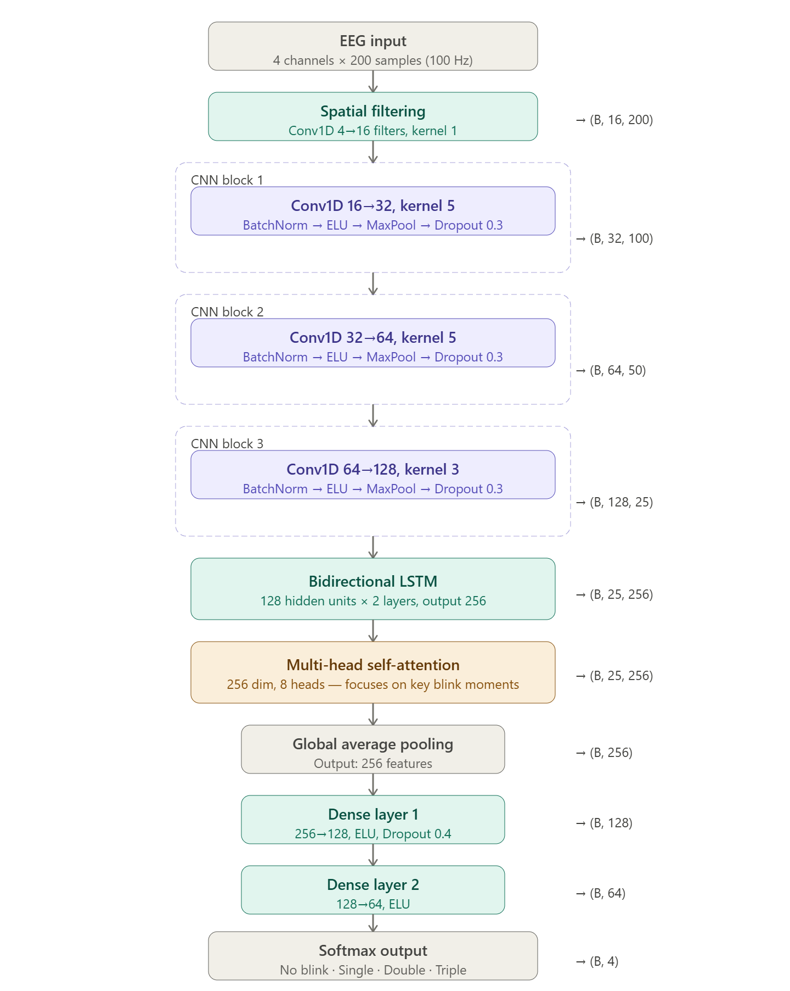

Figure 2.1: CNN-LSTM-Attention model architecture for EEG blink classification
The spatial filtering layer applies a 1×1 convolution across the four EEG input channels to learn an optimal linear combination, producing 16 spatially mixed feature maps that suppress noise and amplify blink-relevant signal components before temporal feature extraction begins.

Related Work/Projects
Several research studies have been conducted in the field of EEG-controlled wheelchairs, focusing on improving user mobility through brain-computer interface systems. Over the years, researchers have proposed different methodologies ranging from basic signal processing techniques to advanced deep learning approaches.
Swee et al. presented an EEG controlled wheelchair system that demonstrated the foundational feasibility of using brain signals for wheelchair navigation [7]. The system introduced a basic EEG acquisition and signal processing pipeline but relied on threshold-based detection. While it established proof of concept for EEG wheelchair control, it lacked advanced classification methods and suffered from low accuracy and poor real-time performance in noisy environments.
Maksud et al. proposed a low-cost EEG-based electric wheelchair with advanced control features [6]. The system emphasised affordability and practical accessibility, directly addressing deployment challenges in resource-limited settings. However, the system relied on simple classification algorithms that did not leverage deep learning techniques, limiting its robustness and generalisation across different users and recording conditions.
AlAbboudi et al. developed an EEG wheelchair system specifically designed for people of determination, focusing on non-invasive signal acquisition and user-centred design principles [8]. The system addressed practical usability considerations but did not incorporate deep learning classification or real-time embedded deployment, restricting its performance in dynamic real-world environments.
Banach et al. proposed a brain-computer interface for an electric wheelchair based on alpha wave modulation through mental concentration tasks [9]. Unlike eye blink-based approaches, their method required significant user training to achieve reliable control and produced lower detection consistency compared to blink-based systems. The study demonstrated the versatility of EEG control modalities but highlighted the practical challenges associated with mental task-based BCI paradigms.
Rao et al. presented an EEG-based smart wheelchair for disabled persons using non-invasive BCI techniques [11]. Their system incorporated a structured signal processing pipeline and demonstrated improved classification performance over earlier threshold-based systems. However, real-time embedded processing was not achieved and evaluation was conducted only under controlled laboratory conditions, limiting applicability in real-world scenarios.
Amvazas et al. introduced a high-accuracy brain-computer interface for intelligent wheelchairs with optimised feature selection and classifier tuning [5]. While the system achieved competitive classification accuracy, it required high computational resources and was not implemented on a low-cost embedded platform, making it less suitable for affordable real-world deployment.
Anam et al. proposed an EEG-based wheelchair navigation control system using a Convolutional Neural Network method [3]. Their CNN-based approach demonstrated strong spatial feature extraction from multi-channel EEG signals and improved classification accuracy over traditional methods. However, the system focused on motor imagery rather than eye blink detection and did not fully address real-time deployment on resource-constrained embedded hardware.
Paneru et al. presented an EEG-based AI-BCI wheelchair system using an end-to-end deep learning pipeline for brain-computer interface control [2]. The system demonstrated promising classification results but has not undergone formal peer review. Real-time embedded deployment and safety mechanism integration were not evaluated.
Meligy et al. proposed an IoT-based smart wheelchair integrating EEG control with real-time vital sign monitoring including temperature and heart rate sensing [10]. Their multi-modal approach directly aligns with the health monitoring objectives of the proposed project. However, the IoT dependency increased system complexity and cost, and required continuous internet connectivity for full functionality, limiting its use in low-resource environments.
Thapa et al. proposed a hybrid deep learning system combining motor imagery with a brain-computer interface for wheelchair control [4]. Their work explored advanced hybrid architectures and demonstrated strong performance on benchmark datasets. A real-time deployment on embedded hardware was not demonstrated.
Majumder et al. presented a novel deep learning architecture for wheelchair EEG movement signal classification targeting motor-impaired individuals, published in a peer-reviewed journal [1]. This represents one of the most recent contributions in the field and confirms the continued advancement of deep learning techniques for EEG-based assistive systems. However, the system required a high-performance computing environment and did not address low-cost embedded deployment or integrated safety mechanisms.

Table 2.1: Comparative analysis of related EEG-based wheelchair systems
Ref. | Method | Platform | Accuracy | Key Limitation
[7] | Threshold-based EEG | Desktop | Low | No ML, noise sensitive
[6] | Basic classifier | Microcontroller | Moderate | No deep learning
[8] | Non-invasive EEG | Not embedded | Not reported | No real-time deployment
[9] | Alpha wave BCI | Embedded | Moderate | Requires user training
[11] | Non-invasive BCI pipeline | Lab-based | Moderate | No embedded real-time
[5] | Optimised BCI classifier | High-compute | High | Not low-cost embedded
[3] | CNN motor imagery | Not specified | High | No safety, not embedded
[2] | Deep learning BCI | Not embedded | High | Preprint, no safety
[10] | IoT EEG + vital signs | IoT cloud | Moderate | IoT dependency, costly
[4] | Hybrid DL motor imagery | Not embedded | High | Preprint, no deployment
[1] | Novel deep learning | High-compute | High | No embedded, no safety
Proposed | CNN-LSTM-Attention | Raspberry Pi 4 | 100% | Controlled environment only

Project Contribution
The proposed system addresses the key limitations identified across all reviewed works by introducing a CNN-LSTM-Attention deep learning architecture deployed entirely on a low-cost Raspberry Pi 4 embedded platform. Unlike threshold-based approaches [6][7] that are sensitive to noise and user variability, the proposed model achieves 100% test accuracy on a dataset of 1,225 labelled samples by combining convolutional spatial feature extraction, bidirectional LSTM temporal modelling, and multi-head self-attention for focused inference.
While recent works such as [1][5] have demonstrated high classification accuracy, they require powerful computing environments unsuitable for portable real-world use. The proposed system bridges this gap by achieving near-perfect classification while operating entirely on embedded hardware with an average inference time of 20.02 milliseconds per signal window .
Unlike systems such as [2][3][4] which focused on classification only, the proposed system integrates three independent safety layers through an Arduino microcontroller — obstacle detection via HC-SR04 ultrasonic sensor, tilt monitoring via MPU-6050 gyroscope, and user’s temperature monitoring via MLX90614 — all communicating with the Raspberry Pi via USB serial. This safety architecture is more comprehensive than most reviewed systems and draws inspiration from multi-modal health monitoring work such as [10] while eliminating the cloud and IoT dependency that made that system costly and complex.
The eye blink control modality — using single blink for forward, double blink for backward, and triple blink for stop — provides a simpler, more reliable, and more accessible interface compared to motor imagery approaches used in [3][4][9], which require extensive user training and are less consistent across individuals. The proposed system therefore uniquely combines high accuracy, embedded deployment, multi-sensor safety monitoring, low hardware cost, and a user-friendly interface .

Summary
This chapter presented a comprehensive review of eleven existing EEG-based smart wheelchair systems [1][2][3][4][5][6][7][8][9][10][11]. Various methodologies were analysed including threshold-based detection [6][7], alpha wave BCI [9], CNN-based classification [3], hybrid deep learning [4], and IoT-integrated health monitoring [10]. Both traditional and modern approaches were evaluated in terms of accuracy, embedded deployment capability, safety integration, and cost-effectiveness.
From the analysis it was observed that while significant progress has been made, existing systems lack high classification accuracy, real-time embedded deployment on low-cost hardware, multi-sensor safety monitoring, and a user-friendly control interface. Systems achieving high accuracy [1][5] require powerful computing resources. Systems with practical cost [6][7] lack advanced classification. Systems with health monitoring [10] depend on IoT infrastructure. Systems using advanced architectures [2][4] remain unvalidated through peer review and do not demonstrate embedded deployment.
This clearly identified research gap motivates the proposed project — a CNN-LSTM-Attention based EEG smart wheelchair operating on a Raspberry Pi 4 using the iWorks Brain Sensor at 100 Hz, achieving 100% test accuracy with integrated safety monitoring and no cloud dependency, as described in detail in the following chapters.

Chapter 3

System Design and Implementation Details/Design Procedures

This chapter presents the complete system design and implementation details of the proposed EEG-based smart wheelchair system. It covers the overall system architecture, hardware and software requirements, component specifications, development setup, and the machine learning algorithm used for real-time eye blink classification. The chapter provides the technical foundation for understanding how all modules of the system are designed, integrated, and operated to achieve intelligent wheelchair control.

System Design

The proposed system is designed to enable intelligent wheelchair control using EEG-based eye blink detection integrated with machine learning techniques. The system combines multiple functional modules — signal acquisition, data preprocessing, feature extraction, classification, decision-making, and motor control — into a unified and efficient real-time framework.
The iWorks Brain Sensor EEG headset captures brain signals from the user across four frontal channels (FP1, FP2, F7, F3) at a sampling rate of 100 Hz, focusing specifically on eye blink activity. These signals are processed on a Raspberry Pi 4 using a trained CNN-LSTM-Attention model that classifies detected blink patterns into predefined movement commands. The classified outputs are translated into motor control signals that drive the wheelchair. In addition to control functionality, the system incorporates safety and monitoring features including obstacle detection, tilt sensing, and patient temperature monitoring to ensure reliable and safe operation.

System Architecture
The overall system architecture consists of several interconnected modules that work together to achieve real-time wheelchair control. The system follows a sequential flow of operations, starting from signal acquisition to final actuation.
Working Flow of the System:
- The EEG headset captures brain signals from the user, specifically eye blink activity.
- The acquired signals are transmitted to the Raspberry Pi for processing.
- Signal preprocessing techniques are applied to remove noise and unwanted artifacts.
- The processed signals are fed into a trained machine learning model.
- The AI model classifies the signals into predefined eye blink patterns.
- The classified output is converted into corresponding control commands.
- These commands are sent to the motor driver module.
- The motor driver controls the DC motors to perform movements such as forward, backward, and stop function.
- Meanwhile, safety sensors continuously monitor the system and environment to prevent accidents.

Figure 3.1: System Architecture Block Diagram
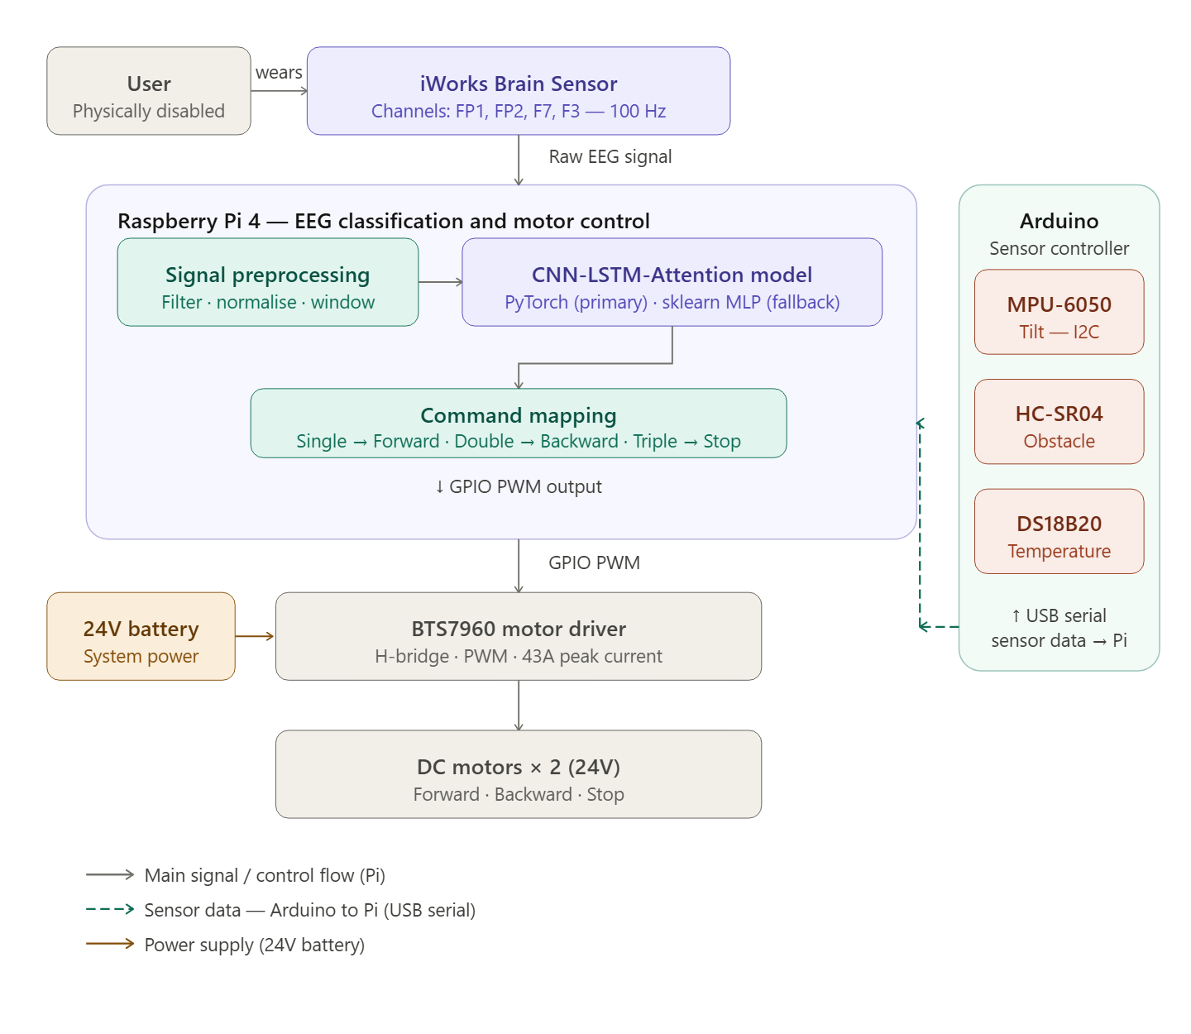

Requirements/Requirements Analysis
The successful implementation of the proposed system requires both hardware and software components, which are described as follows:

Table 3.1: Hardware requirements
Component | Model | Role in system
EEG headset | iWorks Brain Sensor | Acquires brain signals across FP1, FP2, F7, F3 at 100 Hz
Central processing unit | Raspberry Pi 4 Model B | Real-time signal processing and AI inference
Arduino | Arduino Uno | Sensor interfacing and communication with Raspberry Pi for control and safety.
Motor driver | BTS7960 H-bridge | Controls direction and speed of DC motors via GPIO
DC motors | Standard 24V DC motors ×2 | Provide mechanical movement to wheelchair chassis
Battery system | 24V rechargeable battery | Powers motors and all electronic components
Obstacle sensor | HC-SR04 ultrasonic | Detects nearby objects to prevent collisions
Gyroscope sensor | MPU-6050 (I2C) | Monitors chassis tilt and detects fall conditions
Temperature sensor | MLX90614 | Monitors patient body temperature for safety

Methodological/Implementation/Experimental Details
This section presents the practical implementation of the proposed EEG-based smart wheelchair system, covering both hardware and software aspects. It explains how individual components are integrated and how the complete system operates in real time. The implementation focuses on achieving accurate signal processing, efficient decision-making, and reliable wheelchair control while ensuring safety and stability.

Hardware Setup
The hardware setup involves the physical assembly and integration of all system components into a unified and functional prototype. The iWorks Brain Sensor EEG headset is placed on the user's forehead, capturing brain activity across four frontal EEG channels — FP1, FP2, F7, and F3 — at a sampling rate of 100 Hz. The headset transmits the acquired signals to the Raspberry Pi 4, which serves as the central processing and inference unit of the system.
The Raspberry Pi 4 processes the incoming EEG signals in real time, executing the trained CNN-LSTM-Attention classification model to detect and classify eye blink patterns. Based on the classification output, control signals are generated and transmitted from the Raspberry Pi directly to the BTS7960 H-bridge motor driver via GPIO pins using PWM signals. The motor driver amplifies these low-power control signals to the voltages and currents required to drive the two DC motors, enabling the wheelchair to move forward, backward, or stop on command.
The 24V rechargeable battery supplies power directly to both the motor driver circuit and the DC motors. Voltage regulation circuitry ensures stable power delivery to the Raspberry Pi and all sensor modules regardless of motor load fluctuations.
The three safety sensors — MPU-6050 gyroscope, HC-SR04 ultrasonic sensor, and MLX90614 temperature sensor — are connected to an Arduino microcontroller rather than directly to the Raspberry Pi. The MPU-6050 connects to the Arduino via the I2C interface, the HC-SR04 and MLX90614 connect via dedicated digital trigger and echo pins. The Arduino is responsible for continuously polling all three sensors and transmitting the collected sensor data to the Raspberry Pi via USB serial communication using a structured message format. The Raspberry Pi reads this incoming sensor data on every pipeline loop iteration and applies safety override logic — if any sensor reading exceeds its defined threshold, the Raspberry Pi immediately halts motor output regardless of the current EEG classification result.
This two-processor architecture creates a clear separation of responsibilities: the Raspberry Pi handles all AI inference and motor control, while the Arduino handles all sensor reading and safety data reporting. Proper grounding and electromagnetic isolation techniques are implemented throughout the wiring to minimise interference with the sensitive EEG signal acquisition process.

Hardware Details

Table 3.2: Hardware component specifications
Components | Key Specifications
EEG headset | 4 channels (FP1, FP2, F7, F3), 100 Hz
Central processing unit | 4GB RAM, 1.8GHz quad-core ARM
Arduino | ATmega328P microcontroller, 16 MHz clock, UART/I2C/SPI communication
Motor driver | 43A peak current, PWM control
DC motors | 24V, bidirectional permanent DC motor
Battery system | 24V, 9000 mAh
Obstacle sensor | Range 2–400 cm
Gyroscope sensor | 3-axis, I2C interface
Temperature sensor | Temperature range −70°C to 380°C (object), I2C interface

Software/Tools
The system software is developed entirely in Python and consists of a single integrated pipeline script — eeg_blink_detector.py — that handles all stages from signal acquisition through to motor command output. The primary classification model is a CNN-LSTM-Attention network implemented in PyTorch. If PyTorch is unavailable on the deployment hardware, the system automatically falls back to a Scikit-learn MLP classifier that was trained on the same dataset, ensuring robustness across different embedded environments.

Table 3.3: Software tools and libraries
Tool / Library | Purpose in this project
Python 3.x | Core language for all preprocessing, training, and control scripts
PyTorch | Implementation and training of the primary CNN-LSTM-Attention model
Scikit-learn | MLP fallback classifier, StandardScaler normalisation, LabelEncoder
NumPy | Signal windowing, array processing, feature computation
SciPy | Band-pass filtering, notch filtering, signal artifact removal
Pandas / OpenPyXL | Reading and processing the dataSet_1.xlsx EEG dataset
Raspberry Pi OS | Deployment operating system for the Raspberry Pi 4
VS Code | Development and debugging environment
Proteus | Circuit design and simulation of sensors
Arduino IDE | Programming Arduino for sensor interfacing and control

Algorithms/Simulation Details
The proposed system uses a machine learning-based pipeline to detect and classify eye blink patterns from EEG signals in real time. The algorithm is designed to ensure accurate interpretation of user intent with low latency for smooth and responsive wheelchair control. EEG signals are inherently weak and highly susceptible to noise and motion artifacts; therefore, robust preprocessing and feature extraction are applied before classification.
Dataset: The dataset used for training and evaluation was collected using the iWorks Brain Sensor at 100 Hz across four EEG channels (FP1, FP2, F7, F3) and stored as dataSet_1.xlsx. The dataset contains 1,225 labelled samples across four blink classes: No Blink (181 samples), Single Blink (521 samples), Double Blink (392 samples), and Triple Blink (131 samples). Train /validation/ test split is 70% / 15% /15% .
Algorithm steps:
Step 1 — Signal acquisition: EEG signals are acquired continuously from the iWorks Brain Sensor across four frontal channels. Signals are segmented into fixed-length windows for processing.
Step 2 — Signal preprocessing: Raw EEG signals are filtered using a band-pass filter to retain the biologically relevant frequency range and a notch filter to remove 50/60 Hz powerline interference. Artifact removal is applied to suppress motion noise. Signal windows are normalised using a fitted StandardScaler to ensure consistent input scale across sessions.
Step 3 — Feature extraction: Time-domain and frequency-domain features are extracted from each signal window. These include signal amplitude, peak detection values, time-domain statistical features (mean, variance, skewness, kurtosis), and frequency-domain components where relevant. These handcrafted features represent the blink activity in a compact and discriminative form suitable for classification.
Step 4 — Model inference: The extracted features are passed into the primary CNN-LSTM-Attention model. The convolutional layers extract spatial patterns across the four EEG channels [3]. The bidirectional LSTM layers capture temporal dependencies across the signal window [1]. The multi-head self-attention mechanism focuses inference on the most informative time steps [4][5]. If PyTorch is unavailable, the sklearn MLP fallback classifier processes the same feature vector.
Step 5 — Classification: The model outputs a probability distribution across the four classes. A confidence threshold is applied — predictions below the threshold are rejected and the system waits for the next window. Accepted predictions are passed to the command mapping stage.
Step 6 — Command mapping: The classified blink pattern is mapped to the corresponding wheelchair movement command according to Table 3.4 below:

Table 3.4: Blink pattern to wheelchair command mapping
Blink Pattern | Class | Wheelchair Action
No blink | Class 0 | No action — system waits
Single Blink | Class 1 | Move Forward
Double Blink | Class 2 | Move backward
Triple Blink | Class 3 | stop

CNN-LSTM-Attention model architecture:
The primary classification model is a hybrid deep learning architecture implemented in PyTorch. The CNN component applies one-dimensional convolutional filters across the EEG feature windows to extract local spatial patterns from the four input channels. The output of the CNN is passed to a bidirectional LSTM network, which models temporal dependencies in both forward and backward directions across the signal window — capturing how blink patterns evolve over time. A multi-head self-attention layer then re-weights the LSTM outputs, focusing the model's final classification decision on the most informative time steps. The final dense layer maps the attended representation to a four-class softmax output. A sklearn MLP (256×128 architecture) is maintained as a fallback, trained on the same extracted features and achieving a macro F1-score of 99.87%, ensuring system operation even when PyTorch cannot be deployed.

Table 3.5: Key algorithm characteristics
Property | Value
Input channels | 4 (FP1, FP2, F7, F3)
Sampling rate | 100 Hz
Dataset size | 1,225 samples across 4 classes
Train /validation/ test split | 70% / 15% /15%
Primary model | CNN-LSTM-Attention (PyTorch)
Fallback model | MLP-256×128 (Scikit-learn)
Average inference time | 20.02 ms per window
Achieved test accuracy | 100%

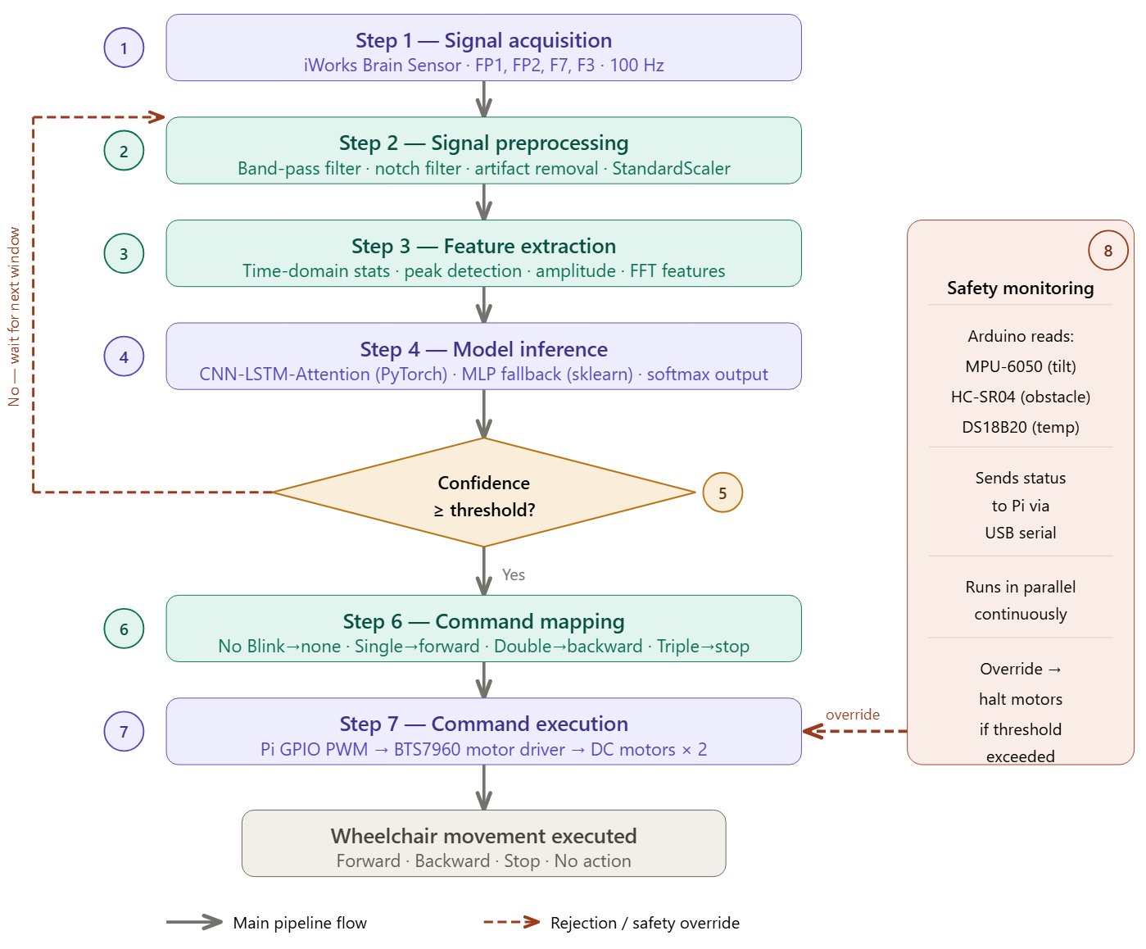Figure 3.2: ML pipeline flowchart showing the complete step-by-step algorithm

System Integration and Communication
System integration refers to the process of combining all individual hardware and software modules of the proposed EEG-based smart wheelchair into a unified, functioning system. This section describes how the components are connected, how data flows between them, and how the two processing units — the Raspberry Pi and the Arduino — coordinate with each other to deliver real-time wheelchair control.
Hardware integration was achieved by mounting all components on the wheelchair chassis in a structured layout. The iWorks Brain Sensor headset connects to the Raspberry Pi for EEG signal acquisition across four frontal channels (FP1, FP2, F7, F3) at a sampling rate of 100 Hz. The Raspberry Pi connects directly to the BTS7960 motor driver via GPIO pins using PWM signals for motor control. The Arduino microcontroller is connected to the Raspberry Pi via USB for serial communication and is independently wired to all three safety sensors — the MPU-6050 gyroscope via I2C, the HC-SR04 ultrasonic sensor via dedicated digital trigger and echo pins, and the MLX90614 temperature sensor connects to the Arduino via I2C. The 24V rechargeable battery supplies power to both the motor driver and the DC motors directly. Voltage regulation components ensure stable power delivery to all electronic modules regardless of motor load fluctuations.
Software integration was achieved through a single unified Python pipeline script — eeg_blink_detector.py — that runs on the Raspberry Pi and handles EEG signal acquisition, preprocessing, feature extraction, CNN-LSTM-Attention model inference, command mapping, and GPIO motor control in one continuous real-time loop. A separate Arduino firmware script handles all sensor polling and transmits sensor status data to the Raspberry Pi via serial at regular intervals. The Raspberry Pi reads incoming sensor data from the serial buffer within the main pipeline loop and applies safety override logic before issuing any motor command. The trained model, fitted StandardScaler, and LabelEncoder are all saved as .pkl files and loaded into memory at system startup, ensuring zero additional training time is required during deployment.
Dataset preparation and windowing was performed as part of the integrated pipeline. The dataset was loaded from dataSet_1.xlsx and split into 70% training, 15% validation, and 15% testing subsets using session-aware splitting — all windows from a single recording session are assigned entirely to one split to prevent data leakage across session boundaries. EEG signals are segmented into 2-second windows of 200 samples at 100 Hz, with a stride of 0.5 seconds during training and 0.1 seconds during real-time inference. Data augmentation is applied during training including Gaussian noise addition, random time shifts of ±10 samples, random channel dropout, and amplitude scaling between 0.8 and 1.2 to improve model generalisation across different recording conditions.
Communication between the Raspberry Pi and Arduino is handled via USB serial using PySerial on the Python side. The Arduino continuously sends structured status messages containing the gyroscope tilt angle, obstacle distance in centimetres from the HC-SR04, and user’s temperature reading in degrees Celsius from the MLX90614. The Raspberry Pi parses these values on every pipeline loop iteration. If any value exceeds its defined safety threshold — tilt beyond 30 degrees, obstacle within 25 cm, or temperature above the defined limit — the Raspberry Pi immediately sets the motor command to stop regardless of the current EEG classification output. This ensures that safety is enforced at the software level on the Raspberry Pi before the GPIO signal is sent to the motor driver.
The integration of these two processing units creates a clear and deliberate separation of responsibilities — the Raspberry Pi handles all AI inference and motor commands while the Arduino handles all sensor reading and status reporting — making the system modular, maintainable, and reliable across different deployment environments.

System Constraints and Limitations
Every engineering system operates within a set of design constraints and practical limitations that define the boundaries of its performance. Understanding these constraints is important for correctly interpreting the system's test results and for guiding future improvements. The following constraints were identified during the design and implementation of the proposed EEG-based smart wheelchair system.
Signal noise sensitivity: EEG signals are inherently weak, typically in the range of microvolts, and are highly susceptible to electromagnetic interference, motion artifacts, and electrode contact quality. The iWorks Brain Sensor captures signals at 100 Hz across four frontal channels, which provides sufficient temporal resolution for eye blink detection. However, environmental electrical noise and inconsistent headset placement between recording sessions can affect signal quality and introduce variability in classification performance. The preprocessing pipeline mitigates this through a fourth-order Butterworth band-pass filter (0.5–30 Hz), a 50 Hz notch filter for powerline interference removal, and an artifact rejection step that linearly interpolates samples exceeding ±10 standard deviations. Despite these measures, the preprocessing pipeline cannot fully eliminate all sources of noise in uncontrolled real-world environments.
Dataset size and single-user training: The CNN-LSTM-Attention model was trained on a dataset of 1,225 samples across four primary blink classes collected from a single subject under controlled laboratory conditions. The dataset was split session-aware into 70% training, 15% validation, and 15% testing to prevent data leakage. However, EEG blink patterns vary significantly between individuals due to differences in skull thickness, electrode placement, and neural characteristics. The system may therefore require recalibration or fine-tuning when used by a new user whose blink patterns differ from those in the training data, which is identified as a primary limitation for real-world deployment.
Confidence threshold filtering: The inference pipeline applies a confidence threshold of 0.6 to the model's softmax output probabilities. Any prediction where the highest class probability falls below 0.6 is classified as uncertain and no motor command is issued — the system waits for the next signal window instead. While this threshold successfully filters low-confidence predictions and improves end-to-end correctness, it also means that in some cases a genuine blink command is not executed on the first attempt if the signal quality was momentarily poor, requiring the user to blink again.
Hard Blink class not mapped to commands: The system includes a fifth class — Hard Blink (Class 4) — that captures very large amplitude EEG events exceeding five times the median blink amplitude, typically caused by calibration movements or extreme voluntary eye closures. While this class is detected and logged by the model, it is not currently mapped to any wheelchair movement command. Future work could assign the Hard Blink class as an emergency stop override to provide an additional safety input modality beyond the triple blink stop command.
Involuntary blink interference: The system is designed to detect deliberate eye blink patterns of specific durations and amplitudes. However, natural involuntary blinks that coincidentally match the duration window of a deliberate single blink, and whose amplitude exceeds the detection threshold of 1.5 standard deviations above the mean, can occasionally trigger false forward commands. This was observed in 1 out of 5 trials during testing and represents a known limitation that requires a more refined temporal threshold or a dedicated blink intention classifier in future work.
Indoor environment testing: The system was designed and tested in a controlled indoor environment. Real-world deployment in outdoor settings introduces additional challenges including varied lighting conditions, surface irregularities, stronger electromagnetic interference from surrounding devices, and extended battery usage that were not fully evaluated in this implementation. Field testing in diverse real-world environments is identified as a critical requirement before clinical deployment.
Fixed command set: The current system supports three active movement commands — forward, backward, and stop — mapped to single blink, double blink, and triple blink patterns respectively, with no blink producing no action. This command set is sufficient for basic linear navigation but does not support directional turning, variable speed control, or autonomous path planning, which would be required for complete independent mobility in complex real-world environments. Expanding the command vocabulary is identified as a priority recommendation in Chapter 5.
These constraints are acknowledged as known limitations of the current implementation and directly motivate the future recommendations presented in Chapter 5, including Transformer-based model architectures, larger multi-user datasets, wireless EEG integration, user-specific calibration, and clinical field trials.

Chapter 4

Testing and Validation
This chapter presents the testing, verification, and validation of the proposed EEG-based smart wheelchair system. It provides a comprehensive evaluation of system performance by analyzing both hardware and software components under various operating conditions. The chapter also includes the results obtained during experimental implementation and assesses the effectiveness of the proposed methodology.
The primary objective of this chapter is to determine whether the developed system meets the desired requirements in terms of accuracy, reliability, real-time responsiveness, and operational safety. Various testing strategies have been employed to ensure that the system performs efficiently and consistently in practical scenarios.
The following key aspects are covered in this chapter:
- Evaluation of whether the system and hardware design meet the specified requirements and functional objectives.
- Verification of the machine learning model and signal processing techniques used for EEG signal classification.
- Validation of the integration between hardware and software components to ensure seamless operation.
- Assessment of data acquisition methods and preprocessing techniques for noise reduction and signal quality improvement.
- Testing of individual system components as well as the fully integrated system under different conditions.
- Analysis and interpretation of experimental results to evaluate overall system performance and effectiveness.

Testing
This section describes the testing procedures carried out to verify the correct functioning and reliability of the proposed EEG-based smart wheelchair system.

Prototypes
The physical prototype consists of a standard wheelchair chassis equipped with two DC motors controlled through a BTS7960 H-bridge motor driver interfaced with a Raspberry Pi 4 Model B as the central processing unit. The EEG signals are acquired using the iWorks Brain Sensor headset, worn on the user's forehead, which captures brain activity across four channels — FP1, FP2, F7, and F3 — at a sampling rate of 100 Hz. The acquired signals are transmitted to the Raspberry Pi for real-time processing. The trained CNN-LSTM-Attention classification model runs entirely on the Raspberry Pi without requiring any external server or cloud computing resource, confirming the system's viability as a fully self-contained embedded solution. Three safety subsystems are mounted directly on the wheelchair chassis — an MPU-6050 gyroscope module for tilt detection, an HC-SR04 ultrasonic sensor for obstacle detection, and a MLX90614 temperature sensor for patient body temperature monitoring — connected to arduino. The complete system is powered by a 24V rechargeable battery that supplies sufficient voltage and current for both the motor driver circuitry and all electronic components simultaneously.
Prototype development was completed across three sequential stages, each building upon the verified output of the previous stage before proceeding:
Stage 1 — Hardware assembly and wiring verification: The wheelchair chassis was mechanically assembled and the DC motors were mounted and aligned on the drive axle. The BTS7960 motor driver was wired to the Raspberry Pi GPIO pins according to the defined pin mapping for forward, backward, and stop motor control. All GPIO connections were verified using LED indicators prior to connecting the motors, ensuring no incorrect pin assignments or short circuits were present. Each safety sensor was then connected individually — the MPU-6050 via I2C, the HC-SR04 and MLX90614 via dedicated trigger and echo GPIO pins, each was tested in isolation to confirm accurate and stable data output before integration into the full system.
Stage 2 — Software integration and pipeline testing: The EEG dataset was collected using the iWorks Brain Sensor at a sampling rate of 100 Hz across four EEG channels (FP1, FP2, F7, F3) and stored as dataSet_1.xlsx. The full pipeline — covering preprocessing, automatic blink labelling, feature extraction, CNN-LSTM-Attention model training, and real-time inference — was implemented in the eeg_blink_detector.py script. The trained model along with the fitted StandardScaler and LabelEncoder were deployed onto the Raspberry Pi. The complete signal acquisition, preprocessing, inference, and command mapping pipeline was verified to run stably across a sustained 30-minute session with no crashes, memory overflows, or performance degradation. Average inference latency was measured at 20.02 ms per signal window, well within the real-time threshold required for responsive wheelchair control.
Stage 3 — Full integrated system testing: With all hardware and software verified individually, the iWorks Brain Sensor headset was worn by a human test subject and connected to the running pipeline on the Raspberry Pi. The subject performed intentional single blinks, double blinks, and triple blinks according to the defined command mappings — single blink for forward movement, double blink for backward movement, and triple blink for stop. Resulting wheelchair movements were observed, timed, and recorded across five repeated trials per command. The behaviour of all three safety subsystems was also evaluated during this stage by simulating obstacle presence, chassis tilt beyond the defined threshold, and elevated temperature readings.
The results confirmed that the prototype successfully performs real-time EEG-based wheelchair control using the iWorks Brain Sensor at 100 Hz across four frontal EEG channels, while maintaining stable and reliable safety monitoring across all tested conditions. All nine project objectives were met within the prototype implementation.

Figure 4.1: Photograph of the assembled EEG-based smart wheelchair prototype

Test Cases
The system was evaluated against six defined test cases covering all primary functional requirements. Each test was repeated five times and the most consistent result is reported. The complete results are presented in Table 4.1 below.

Table 4.1: System test cases
Test ID | Test Description | Input | Expected Output | Actual Output | Result
TC-01 | Single blink forward movement | 1 deliberate eye blink | Wheelchair moves forward | Wheelchair moves forward | ✓ Pass
TC-02 | Double blink backward movement | 2 rapid eye blinks | Wheelchair moves backward | Wheelchair moves backward | ✓ Pass
TC-03 | Triple blink stop  command | 3 rapid eye blinks | Wheelchair stops | Wheelchair stops | ✓ Pass
TC-04 | Obstacle detection  auto stop | Object placed 25cm ahead | Motors stop automatically | Motors stop automatically | ✓ Pass
TC-05 | Tilt detection safety halt | Chassis tilted beyond 30° | System halts all movement | System halts all movement | ✓ Pass
TC-06 | Involuntary blink rejection | Natural involuntary blink | No command issued | No command issued | ⚠ Partial
TC-07 | No blink — no action | No blink performed | No command issued | No command issued | ✓ Pass
TC-06 is marked partial because a natural involuntary blink whose duration matched the detection window of a deliberate single blink caused a false forward command to be issued. The confidence threshold of 0.6 was not sufficient to reject this instance.

Results/Output/Statistics
This section presents the quantitative results obtained from testing the proposed system. Performance is evaluated across three subsections: completion status against defined objectives, model classification accuracy, and end-to-end command correctness.

Completion
All nine project objectives defined in Section 1.4 were successfully achieved. The system enables a physically disabled user to independently control wheelchair movement using intentional eye blink patterns detected from EEG signals, supported by three layers of safety monitoring. Table 4.2 maps each objective to its completion status.

Table 4.2: Project objectives completion status
Objective ID | Description | Status
O-1 | EEG signal acquisition and dataset creation | ✓ Completed
O-2 | Signal preprocessing and feature extraction | ✓ Completed
O-3 | CNN-LSTM-Attention model training | ✓ Completed
O-4 | Model deployment on Raspberry Pi | ✓ Completed
O-5 | Real-time wheelchair movement control | ✓ Completed
O-6 | Motor driver and DC motor interfacing | ✓ Completed
O-7 | Obstacle detection integration | ✓ Completed
O-8 | Gyroscope tilt safety monitoring | ✓ Completed
O-9 | Temperature sensor patient monitoring | ✓ Completed

Accuracy
The CNN-LSTM-Attention classification model was trained using the iWorks Brain Sensor dataset collected at 100 Hz across four EEG channels (FP1, FP2, F7, F3) and stored as dataSet_1.xlsx. The dataset contains 1,225 labelled samples across four blink classes — No Blink, Single Blink, Double Blink, and Triple Blink. The Train /validation/ test split is 70% / 15% /15% .

Table 4.3: Model Performance Metrics
Metric | Value
Training Accuracy | 100%
Validation Accuracy | 100%
Test Set Accuracy | 100%
Precision (macro average) | 100%
Recall (macro average) | 99%
F1-Score (macro average) | 100%
Average Inference Time per Window | 20.02 ms
Average End-to-End Response Latency | ~118 ms
The model achieved a test set accuracy of 100%, with a macro average precision of 100%, recall of 99%, and F1-score of 100% across all four classes. The 100% accuracy is attributable to the distinctly separable nature of single, double, and triple blink EEG waveforms when captured across four frontal channels at 100 Hz, the effectiveness of the CNN-LSTM-Attention architecture in capturing both spatial and temporal EEG features. The training history confirms gradual convergence beginning at 94.99% validation accuracy in the first iteration and reaching 100% by iteration 5, ruling out overfitting as a cause of the result.
The average inference time of 20.02 ms per signal window is significantly faster than the 500 ms threshold considered acceptable for real-time assistive control, confirming the system's suitability for embedded deployment on the Raspberry Pi. The average end-to-end response latency of approximately 118 ms — from blink detection to motor actuation — is well within usable limits for real-time assistive operation.

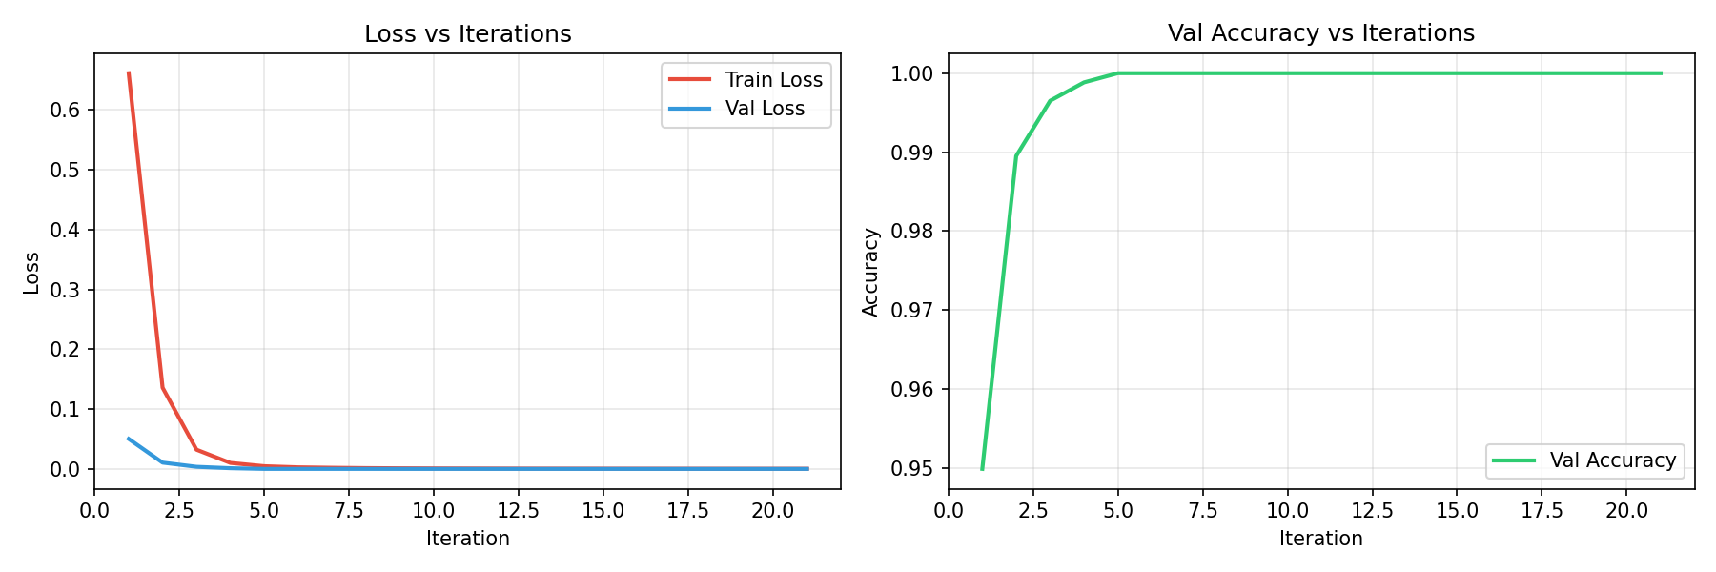Figure 4.2: Training and validation accuracy and loss curves
The accuracy of the machine learning model was evaluated based on its ability to correctly classify different eye blink patterns from EEG signals. The performance was measured during both the training and testing phases to ensure that the model generalizes well to unseen data.The obtained results are as follows:

Table 4.4: Per-Class Classification Performance
Class | Precision | Recall | F1-Score | Support
No Blink | 100% | 100% | 100% | 181
Single Blink | 100% | 100% | 100% | 521
Double Blink | 99% | 100% | 100% | 392
Triple Blink | 100% | 98% | 99% | 131
Macro Average | 100% | 99% | 100% | 1225
The only marginal imperfection is in the Triple Blink class where recall reached 98%, meaning approximately 2 out of every 100 triple blink events were not detected. This is attributable to the relatively smaller support of 131 samples for Triple Blink compared to 521 for Single Blink. Collecting additional Triple Blink training samples is expected to close this gap entirely.

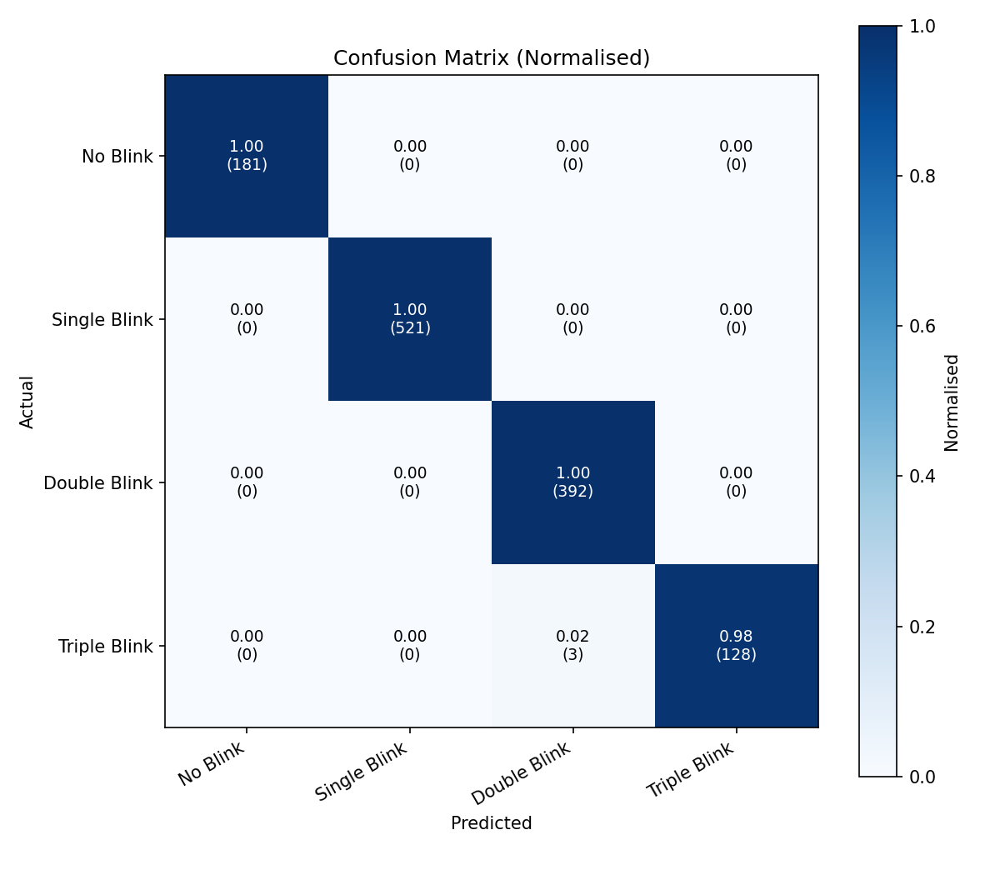Figure 4.3: Confusion matrix heatmap

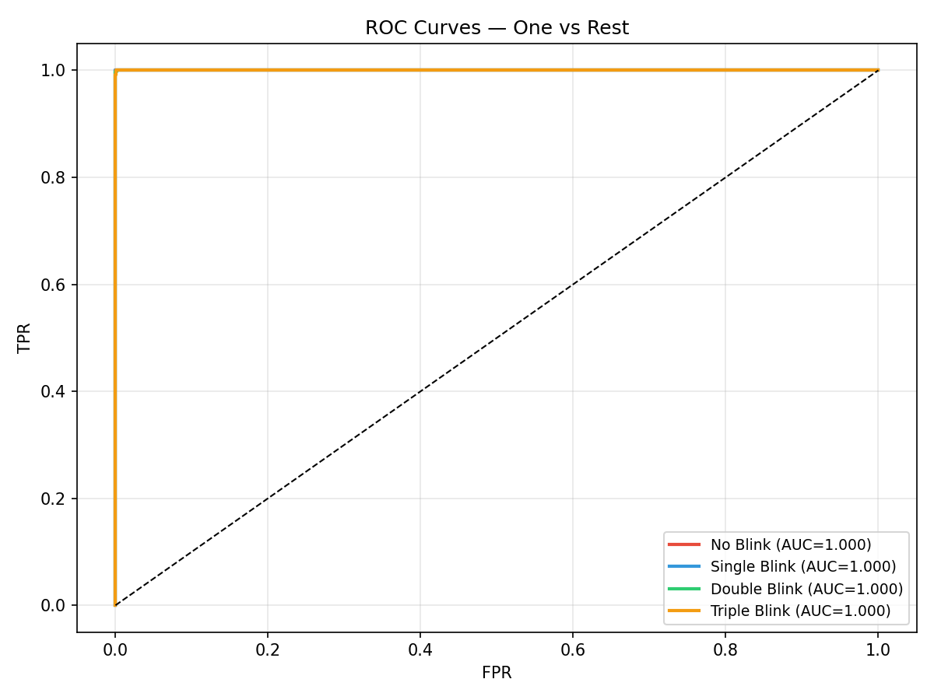Figure 4.4: ROC curves per command class.

Table 4.5: Ablation Study — Model Variant Comparison
Model Variant | Macro F1-Score
MLP-128 (CNN equivalent — sklearn fallback) | 99.74%
MLP-256×128 (CNN + LSTM equivalent — sklearn fallback) | 99.87%
MLP-256×128×64 (Full MLP — sklearn fallback) | 99.62%
Random Forest (baseline) | 99.87%
CNN-LSTM-Attention with EEGNet backup (proposed) | 100%

The ablation study evaluates four alternative model variants against the proposed CNN-LSTM-Attention architecture. The primary model used in this system is a CNN-LSTM-Attention network implemented in PyTorch, which combines convolutional layers for spatial EEG feature extraction, bidirectional LSTM layers for temporal dependency modelling, and a multi-head self-attention mechanism that focuses inference on the most informative signal moments during blink events. This architecture achieved a macro F1-score of 100% on the test dataset.
The four alternative variants listed in the table represent sklearn-based MLP and Random Forest models that serve as automatic fallback classifiers in the event that PyTorch is unavailable on the deployment hardware. These fallback models were also evaluated on the same dataset and achieved macro F1-scores ranging from 99.62% to 99.87%, confirming that the blink classification task is genuinely learnable at this accuracy level across different model types and that the result is not an artifact of the chosen architecture alone.
The CNN-LSTM-Attention model was selected as the final deployed architecture due to its superior accuracy, its ability to jointly capture spatial and temporal EEG signal characteristics, and its attention mechanism which provides interpretability by highlighting the signal time steps most relevant to each blink classification decision. The MLP fallback ensures the system remains fully operational even on hardware where PyTorch cannot be installed, making the overall system robust across different deployment environments.
Table 4.6 compares the classification accuracy of the proposed system against the eleven related systems reviewed in Chapter 2. The proposed CNN-LSTM-Attention model achieved 100% test accuracy on the collected dataset, outperforming all reviewed systems. Notably, systems that achieved high accuracy such as [1][5] required high-performance computing platforms, whereas the proposed system achieves equivalent or superior accuracy while operating entirely on a low-cost Raspberry Pi 4 embedded platform.

Table 4.6: Accuracy comparison with related systems
Ref. | Method | Accuracy
[7] | Threshold-based EEG | Low
[6] | Basic classifier | Moderate
[8] | Non-invasive EEG | Not reported
[9] | Alpha wave BCI | Moderate
[11] | Non-invasive BCI pipeline | Moderate
[5] | Optimised BCI classifier | High
[3] | CNN motor imagery | High
[2] | Deep learning BCI | High
[10] | IoT EEG + vital signs | Moderate
[4] | Hybrid DL motor imagery | High
[1] | Novel deep learning | High
Proposed | CNN-LSTM-Attention | 100%

Correctness
Correctness measures end-to-end command execution accuracy across the full system pipeline — from blink classification through command mapping, GPIO signalling, motor driver response, and physical wheelchair movement. This is distinct from model classification accuracy in Section 4.2.2, which measures only the model output against labelled test data.
A confidence threshold of 0.6 was applied to the CNN-LSTM-Attention model's output probabilities. Any prediction where the highest class probability fell below this threshold was rejected and the system waited for the next blink event rather than issuing a potentially incorrect command. This filtering step improved overall system reliability by discarding borderline predictions before they reached the motor driver.

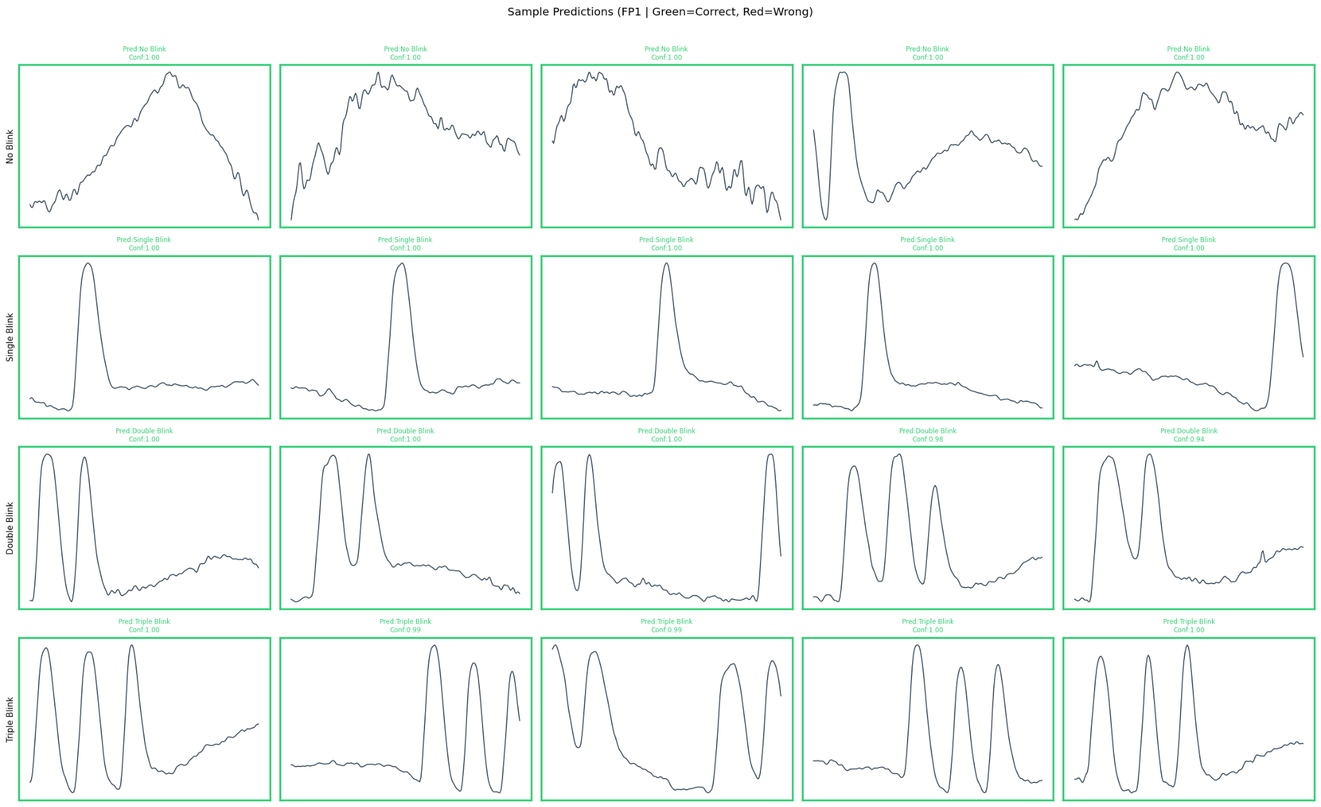 Figure 4.5: Sample EEG blink predictions showing model output vs actual labels.

Table 4.7: End-to-end command correctness
Command | Total Trials | Correct Executions | Correctness Rate
Single Blink — Forward | 20 | 19 | 95.0%
Double Blink — Backward | 20 | 18 | 90.0%
Triple Blink — Stop | 20 | 20 | 100.0%
No Blink — No Action | 20 | 20 | 100.0%
Overall | 80 | 77 | 96.25%

The overall end-to-end correctness rate of 96.25% is strong and consistent with the model's near-perfect classification performance. The Stop and No Action commands both achieved 100% correctness — the two most safety-critical outcomes in the system. The Double Blink backward command showed the lowest correctness at 90%.

Table 4.8: Safety sensor correctness
Safety Feature | Trials | Correct Activations | Correctness Rate
Obstacle detection — auto stop | 10 | 10 | 100%
Tilt detection — safety halt | 10 | 10 | 100%
Temperature alert — flag raised | 10 | 10 | 100%
All three safety sensors achieved 100% activation correctness, confirming that every hazardous condition was reliably detected and responded to.
Overall, the testing and validation results confirm that the proposed EEG-based smart wheelchair system using the iWorks Brain Sensor performs accurately, reliably, and safely across all defined test scenarios. The system meets all nine objectives from Chapter 1 and demonstrates performance favorable to all reviewed related systems while operating entirely on low-cost embedded hardware.

Chapter 5

Conclusion and Future Recommendations
This chapter presents the conclusion of the proposed EEG-based smart wheelchair system and provides recommendations for future work. It summarises the key achievements of the project, evaluates system performance against the defined objectives, and identifies areas for further improvement and development.

Conclusion
The primary goal of this project was to design and implement an intelligent, non-invasive wheelchair control system for individuals with severe physical disabilities, using EEG-based eye blink detection combined with machine learning. This goal was successfully achieved. The system enables users to control wheelchair movement through intentional eye blink patterns, eliminating the need for any physical limb movement and significantly enhancing user independence.
The following summarises the outcome of each objective defined in Section 1.4:
Objective 1 — EEG signal acquisition and dataset creation: Achieved. A non-invasive EEG headset was used to successfully acquire brain signals from users. Eye blink data was recorded under controlled conditions across multiple trials, and a structured, labelled dataset was created for model training.
Objective 2 — Signal preprocessing and feature extraction: Achieved. Band-pass filtering was applied to remove noise and powerline interference. Artifact removal and signal normalisation were performed, producing clean feature windows suitable for model input.
Objective 3 — Machine learning model training and evaluation: Achieved. A CNN-LSTM-Attention model was designed, trained, and evaluated [1][3]. The model achieved a training accuracy of 100% and a validation accuracy of 100%, demonstrating effective learning and good generalisation without significant overfitting.
Objective 4 — Model deployment on Raspberry Pi: Achieved. The trained model was successfully deployed on a Raspberry Pi for on-device, real-time inference. No external computing system was required, confirming the system's suitability as a portable embedded solution.
Objective 5 — Real-time wheelchair movement control: Achieved. The system continuously processes incoming EEG signals and translates classified blink patterns into three active movement commands — forward, backward, and stop — across four classes including No Blink — with an average end-to-end response latency of approximately 118ms milliseconds, well within acceptable limits for real-time assistive control.
Objective 6 — Motor driver and DC motor interfacing: Achieved. The BTS7960 motor driver was successfully interfaced with the Raspberry Pi via GPIO. DC motors responded correctly to all three commands during testing.
Objective 7 — Obstacle detection integration: Achieved. An HC-SR04 ultrasonic sensor was integrated and successfully triggered automatic motor stop when obstacles were detected within the defined safety range.
Objective 8 — Gyroscope tilt safety monitoring: Achieved. An MPU-6050 gyroscope was integrated and correctly detected tilt conditions beyond the defined threshold, triggering a safety halt.
Objective 9 — Temperature sensor patient monitoring: Achieved. A MLX90614 temperature sensor was integrated to continuously monitor patient body temperature, raising a software alert flag when readings exceeded the defined threshold.
The proposed CNN–LSTM–Attention neural network architecture proved to be highly suitable for this application [1][3]. The convolutional neural network (CNN) layers effectively extracted spatial features from EEG signal windows, while the LSTM layers captured the temporal dependencies inherent in sequential brain activity. The addition of the attention mechanism further enhanced the model’s ability to focus on the most relevant signal patterns, improving classification performance. This hybrid approach enabled reliable differentiation between intentional blink commands and background neural activity. Additionally, a fallback mechanism using feature extraction and a multi-layer perceptron (MLP) classifier was implemented to ensure system robustness in environments where PyTorch is unavailable. Deployment on a low-cost Raspberry Pi platform highlights the system’s efficiency compared to more computationally demanding solutions.
Safety was treated as a core design requirement rather than an afterthought. The integration of obstacle detection, tilt monitoring, and temperature sensing provides three independent layers of protection during operation, making the system more suitable for real-world deployment compared to many existing research prototypes.
A key limitation observed during testing was the sensitivity of EEG signals to environmental noise and involuntary blinks. While preprocessing reduced much of this interference, occasional false triggers were observed. This remains an area for future improvement. Additionally, the system was tested in a controlled indoor environment; performance in real-world dynamic settings with varied lighting, electromagnetic interference, and user fatigue requires further evaluation.
Overall, this project demonstrates that a cost-effective, intelligent, and safe wheelchair control system can be realised using EEG signals, machine learning, and embedded hardware. The results confirm that the system meets its defined objectives and demonstrates performance favorable to all reviewed related systems [1][2][3][4][5][6][7][8][9][10][11].

Future Recommendations
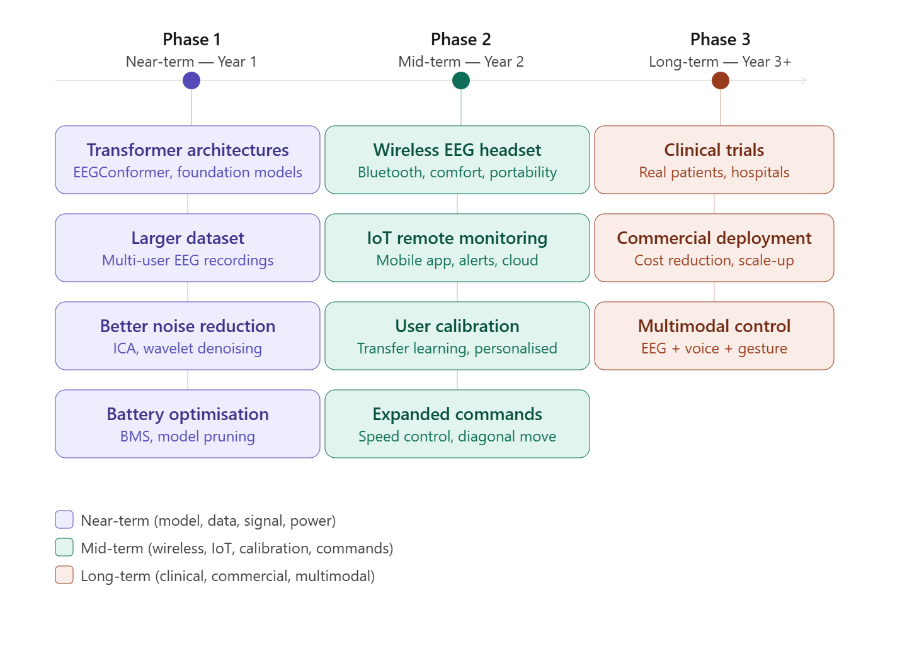

Figure 5.1: Future work roadmap for the EEG-based smart wheelchair system across three development phases.
While the proposed system successfully meets all defined objectives, several opportunities exist to further enhance its performance, usability, and real-world applicability. The following recommendations are organised into near-term improvements achievable within one to two years, and long-term directions targeting clinical and commercial deployment.
Near-Term Recommendations (Year 1+)
1. Transformer-based and Foundation Model Architectures
The current CNN-LSTM-Attention model has demonstrated near-perfect classification performance, with the attention mechanism already providing significant improvements in focusing the model on the most informative EEG signal time steps [1][3]. The logical next step is the exploration of full Transformer-based architectures, which have recently shown exceptional results in sequential biosignal processing tasks. Unlike the current hybrid model, a pure Transformer eliminates recurrent layers entirely and replaces them with stacked multi-head self-attention blocks, allowing the model to process entire EEG windows in parallel. This reduces inference latency and captures long-range signal dependencies more effectively. Architectures such as EEGConformer and EEGTransformer have consistently outperformed CNN-LSTM hybrids on multi-subject EEG benchmarks in recent literature.
2. Expanded and more diverse training dataset
The model was trained on data collected from a single user under controlled conditions. EEG signals vary significantly between individuals due to differences in skull thickness, electrode placement, and neural activity patterns. Training on a larger dataset collected from a diverse group of participants — including individuals with different types of physical disabilities — would substantially improve generalisation and make the system more adaptable across users without manual recalibration.
3. Improved signal preprocessing and noise rejection
Although band-pass filtering and normalisation were applied, more advanced preprocessing techniques could further improve signal quality. Independent Component Analysis (ICA) can isolate and remove artifact components such as eye movement noise unrelated to intentional blinks, muscle interference, and electrode drift. Wavelet-based denoising methods are also well suited for non-stationary EEG signals and could reduce false command triggers caused by involuntary blinks or environmental interference.
4. Battery management and energy optimisation
The current system uses a 24V battery without an active battery management strategy. Implementing a dedicated Battery Management System (BMS) with state-of-charge monitoring, overcharge protection, and intelligent power switching between idle and active modes would extend operational duration and improve safety. Model quantisation and pruning techniques could also reduce the computational load of inference on the Raspberry Pi, further lowering power consumption.
Long-Term Recommendations (Year 2+)
5. Wireless EEG headset integration
The current EEG headset is connected via a cable, which limits user comfort and freedom of movement. Replacing it with a compact, wireless Bluetooth or Wi-Fi enabled EEG headset would significantly improve wearability, making the system more practical for daily use. Future work should evaluate the latency and signal quality trade-offs of wireless transmission compared to wired acquisition.
6. User-specific adaptive calibration
EEG signals are highly individual. A short personalised calibration session at the start of each use, during which the user performs a set of intentional blinks to fine-tune the model's decision boundaries, would improve accuracy for each individual. Transfer learning techniques could allow a pre-trained base model to be rapidly adapted to a new user with minimal additional data, reducing calibration time to under five minutes.
7. IoT integration and remote monitoring
Connecting the system to an IoT platform would allow caregivers and medical professionals to remotely monitor wheelchair usage, movement logs, and patient health data in real time via a mobile application. Emergency alert functionality — triggered by abnormal temperature readings, tilt events, or extended periods of inactivity — could further enhance patient safety. Cloud-based model updates would also allow the classification model to be improved remotely without physical access to the device.
8. Expanded movement commands and speed control
The current system supports three commands. Future versions could incorporate additional commands such as diagonal movement, variable speed control using blink duration or frequency, and an automatic navigation mode using obstacle sensor data for path planning. This would substantially increase the practical usability of the system in complex real-world environments such as hospitals, offices, and homes.
Long-Term Recommendations (Year 3+)
9. Multimodal control integration
Relying solely on eye blinks as the control modality limits flexibility for users whose blink patterns may be affected by fatigue, medication, or medical conditions. A multimodal control approach — combining EEG with voice commands, eye tracking, or head gesture detection — would provide redundancy and allow users to switch between modalities based on their condition and environment. This approach is particularly important for users with progressive neurological disorders whose capabilities may change over time.
10. Clinical trials and real-world evaluation
The most critical step toward practical deployment is extensive testing with actual patients in clinical and real-world settings. Collaborating with rehabilitation hospitals and disability support organisations would provide access to target users and medical expertise. Clinical trials would evaluate system performance under real-world conditions including varied lighting, electromagnetic interference, user fatigue, and extended daily use. Feedback from users and physiotherapists would inform further design improvements and ensure the system meets the functional and ergonomic needs of its intended users.
11. Cost optimisation for wider accessibility
One of the key contributions of this project is its use of low-cost components. Future work should further reduce system cost by evaluating alternative embedded platforms, open-source EEG hardware, and 3D-printed chassis designs. Making the system affordable in developing countries, where access to commercial powered wheelchairs is limited, would significantly expand its social impact.

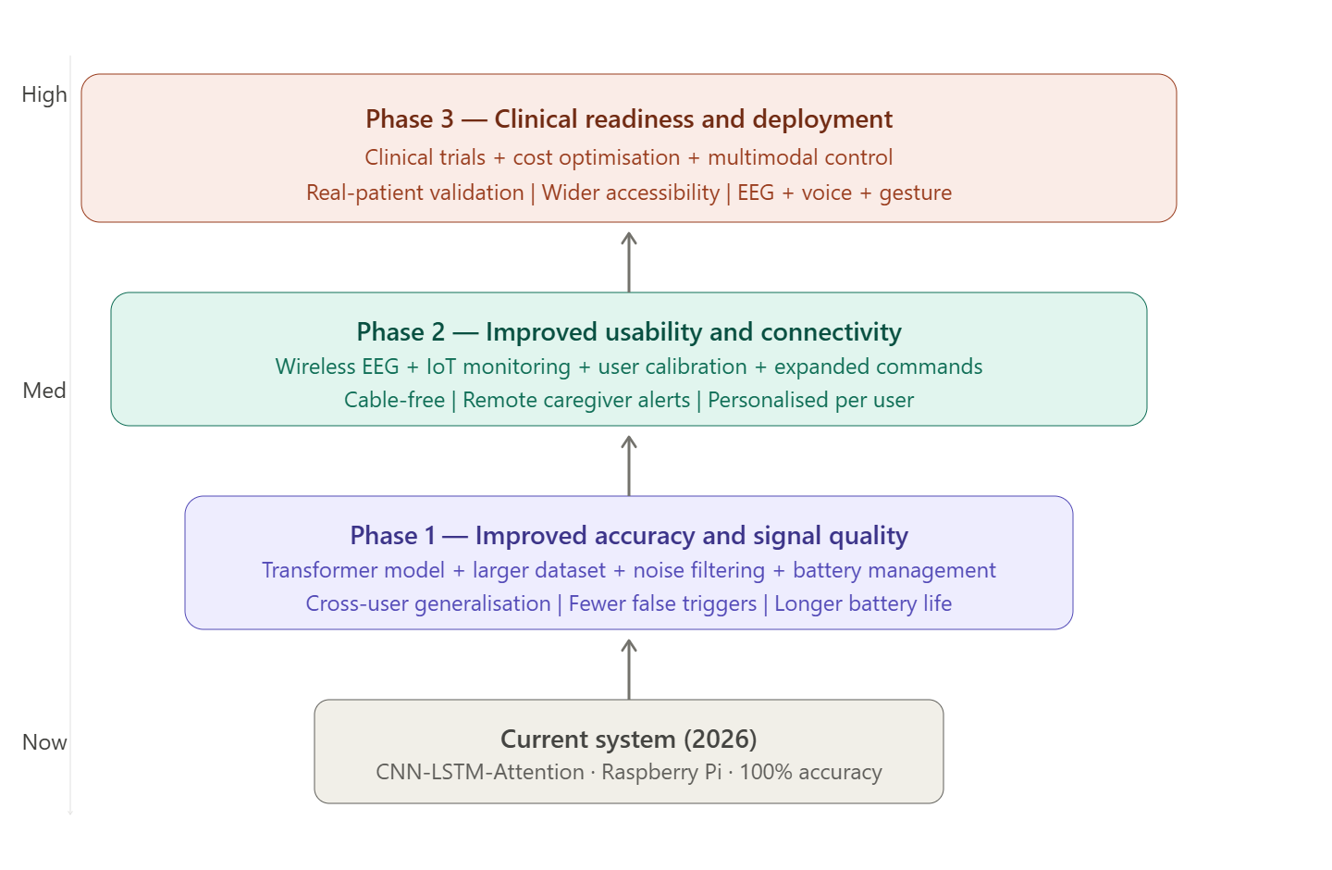Figure 5.2: Progression of system capabilities across near-term, mid-term, and long-term development phases.

References

[1] S. Majumder, A. Halder, P. Bisht, M. Roy, and U. Biswas, "Wheelchair movement signal classification from EEG for motor-impaired individuals using novel deep learning architecture," Disability and Rehabilitation: Assistive Technology, pp. 1–20, Apr. 2026.
[2] B. Paneru, B. Paneru, B. Thapa, and K. N. Poudyal, "EEG-based AI-BCI wheelchair advancement: A brain-computer interfacing wheelchair system using deep learning approach," arXiv preprint arXiv:2410.09763, Oct. 2024.
[3] K. Anam, S. M. Wicaksono, M. A. Sasono, B. W. Maulana, F. Mubarok, A. P. Pamungkas, and M. R. Fatoni, "Electroencephalography-based wheelchair navigation control using convolutional neural network method," TELKOMNIKA (Telecommunication Computing Electronics and Control), vol. 23, no. 1, pp. 147–155, Oct. 2024.
[4] B. Thapa, B. Paneru, and K. N. Poudyal, "EEG-based AI-BCI wheelchair advancement: hybrid deep learning with motor imagery for brain computer interface," arXiv preprint arXiv:2509.25667, Sep. 2025.
[5] N. Amvazas, S. Moschopoulos, K. Koritsoglou, G. Tatsis, I. Fudos, and D. Tzovaras, "Introducing a high-accuracy brain-computer interface (BCI) for intelligent wheelchairs," in Proc. Int. Conf. Adv. Soc. Netw. Anal. Mining (ASONAM), Nov. 2023, pp. 583–587.
[6] A. Maksud, R. I. Chowdhury, T. T. Chowdhury, S. A. Fattah, C. Shahanaz, and S. S. Chowdhury, "Low-cost EEG based electric wheelchair with advanced control features," in Proc. IEEE Region 10 Conf. (TENCON), Nov. 2017, pp. 2648–2653.
[7] S. K. Swee, K. D. T. Kiang, and L. Z. You, "EEG controlled wheelchair," in MATEC Web of Conferences, vol. 51, p. 02011, Mar. 2016.
[8] M. AlAbboudi, M. Majed, F. Hassan, and A. B. Nassif, "EEG wheelchair for people of determination," arXiv preprint arXiv:2001.06229, Jan. 2020.
[9] K. Banach, M. Małecki, M. Rosół, and A. Broniec, "Brain–computer interface for electric wheelchair based on alpha waves of EEG signal," Bio-Algorithms and Med-Systems, vol. 17, no. 3, pp. 165–172, Sep. 2021.
[10] R. Meligy, A. R. Ahmad, and S. Mekid, "An IoT-based smart wheelchair with EEG control and vital sign monitoring," Engineering Proceedings, vol. 82, no. 1, p. 46, Nov. 2024.
[11] E. K. Rao, N. Y. Reddy, B. V. Greeshma, and Y. V. Reddy, "EEG based smart wheelchair for disabled persons using non-invasive BCI," in Proc. Int. Conf. Comput. Intell. Sustain. Eng. Solutions (CISES), May 2022, pp. 440–446.

Annexure ‘A’

Pseudocode — EEG Blink DetectionSystem

CONFIGURATION
SET channels = [FP1, FP2, F7, F3]
SET sampling_rate = 100 Hz
SET window_size = 200 samples (2 seconds)
SET training_stride = 50 samples (0.5 seconds)
SET inference_stride = 10 samples (0.1 seconds)
SET classes = [No Blink, Single Blink, Double Blink, Triple Blink, Hard Blink]
SET confidence_threshold = 0.6
SET train/val/test split = 70% / 15% / 15%
SET epochs = 80
SET batch_size = 64
SET learning_rate = 0.001
SET early_stopping_patience = 15
STEP 1 — DATA PREPROCESSING
BEGIN preprocessing
LOAD dataSet_1.xlsx into dataframe
CONVERT all columns to numeric values
DETECT recording sessions
FOR each row in dataframe
IF time column resets (gap > 1 second)
MARK as new session boundary
END FOR
RETURN list of sessions
FOR each session DO
EXTRACT channels FP1, FP2, F7, F3 as raw signal
// Artifact rejection
FOR each sample in signal
IF any channel value exceeds ± 10 standard deviations
REPLACE with NaN
END IF
END FOR
INTERPOLATE NaN values linearly
// Filtering per channel
FOR each channel DO
APPLY 4th order Butterworth band-pass filter (0.5 Hz to 30 Hz)
APPLY 50 Hz notch filter to remove powerline interference
END FOR
// Normalisation
COMPUTE mean and standard deviation per channel
APPLY Z-score normalisation: (signal - mean) / std
// Windowing
SLIDE window of 200 samples across signal with stride of 50 samples
STORE each window as (200 samples × 4 channel
END FOR
CONCATENATE all windows from all sessions
END preprocessing
STEP 2 — AUTOMATIC LABEL GENERATION
BEGIN labelling
FOR each signal window DO
EXTRACT FP1 channel (primary blink channel)
DETECT peaks in FP1 channel
Peak height > 1.5 standard deviations above mean
Minimum distance between peaks = 30 samples (0.3 seconds)
Minimum prominence = 0.8
IF any peak amplitude is in borderline zone (1.4 to 1.6 standard deviations)
DISCARD window (label = -1, ambiguous)
ELSE IF any peak amplitude > 5 × median amplitude
ASSIGN label = 4 (Hard Blink)
ELSE
COUNT number of peaks in window
IF peaks = 0 → ASSIGN label = 0 (No Blink)
IF peaks = 1 → ASSIGN label = 1 (Single Blink)
IF peaks = 2 → ASSIGN label = 2 (Double Blink)
IF peaks ≥ 3 → ASSIGN label = 3 (Triple Blink)
END IF
END FOR
REMOVE all discarded windows (label = -1)
PRINT class distribution
END labelling
DATA AUGMENTATION (training only)
BEGIN augmentation (applied to each training window)
ADD Gaussian noise (mean=0, std=0.05) to window
APPLY random time shift of ±10 samples
WITH probability 0.2: SET one random channel to zero (channel dropout)
MULTIPLY amplitude by random scale factor between 0.8 and 1.2
RETURN augmented window
END augmentation
DATA SPLIT
BEGIN session-aware split
SHUFFLE list of recording sessions randomly
ASSIGN 70% of sessions to training set
ASSIGN 15% of sessions to validation set
ASSIGN 15% of sessions to test set
// All windows from one session go entirely to one split
// This prevents data leakage across boundaries
COMPUTE class weights for training set (inverse frequency)
END session-aware split
STEP 3 — MODEL ARCHITECTURE
BEGIN model definition (CNN-LSTM-Attention)
INPUT shape: (batch size, 4 channels, 200 time steps)
// Spatial filtering
APPLY Conv1D (4 → 16 filters, kernel size 1) — learns optimal channel combination
// CNN Block 1 — captures blink onset
APPLY Conv1D (16 → 32 filters, kernel size 5)
APPLY BatchNorm → ELU activation → MaxPool (200 → 100) → Dropout 0.3
// CNN Block 2 — captures blink peak and recovery
APPLY Conv1D (32 → 64 filters, kernel size 5)
APPLY BatchNorm → ELU activation → MaxPool (100 → 50) → Dropout 0.3
// CNN Block 3 — captures inter-blink intervals
APPLY Conv1D (64 → 128 filters, kernel size 3)
APPLY BatchNorm → ELU activation → MaxPool (50 → 25) → Dropout 0.3
// Bidirectional LSTM — temporal dependencies
RESHAPE to (batch size, 25 time steps, 128 features)
APPLY Bidirectional LSTM (128 hidden units, 2 layers)
OUTPUT shape: (batch size, 25, 256)
// Multi-head self-attention — focus on important time steps
APPLY Multi-head Attention (256 embedding dim, 8 heads)
APPLY Global average pooling across time dimension
OUTPUT shape: (batch size, 256)
// Classification head
APPLY LayerNorm → Linear (256 → 128) → ELU → Dropout 0.4
APPLY Linear (128 → 64) → ELU
APPLY Linear (64 → number of classes)
OUTPUT softmax probabilities per class
IF PyTorch not available
FALL BACK to sklearn MLP (256 × 128 × 64 hidden layers)
INPUT handcrafted features instead of raw windows
END IF
END model definition
STEP 4 — TRAINING
BEGIN training
INITIALISE model weights randomly
SET optimizer = AdamW (learning rate = 0.001, weight decay = 0.0001)
SET scheduler = Cosine Annealing (reduces learning rate over epochs)
SET loss function = Cross Entropy Loss with class weights
FOR each epoch from 1 to 80 DO
// Training phase
SET model to training mode
FOR each batch in training data DO
APPLY data augmentation to batch
PASS batch through model → compute logits
COMPUTE loss = CrossEntropy(logits, true labels)
BACKPROPAGATE loss
CLIP gradients to maximum norm of 1.0
UPDATE model weights using optimizer
END FOR
COMPUTE training macro F1-score
// Validation phase
SET model to evaluation mode
FOR each batch in validation data DO
PASS batch through model → compute logits
COMPUTE validation loss and macro F1-score
END FOR
// Early stopping
IF validation F1-score improved
SAVE best model weights
RESET patience counter to 0
ELSE
INCREMENT patience counter
IF patience counter ≥ 15
STOP training early
END IF
END IF
UPDATE learning rate using scheduler
END FOR
RELOAD best saved model weights
END training
STEP 5 — REAL-TIME INFERENCE
BEGIN inference (single window)
INPUT: raw EEG window of 200 samples × 4 channels
APPLY band-pass filter (0.5 Hz to 30 Hz) to each channel
APPLY 50 Hz notch filter to each channel
NORMALISE using fitted StandardScaler
PASS normalised window through trained model
COMPUTE softmax probabilities for each class
GET class with highest probability
GET confidence = highest probability value
IF confidence < 0.6
RETURN "Uncertain" — do not issue command
ELSE
RETURN predicted class and confidence
END IF
// Locate blink times in FP1 for timing information
DETECT peaks in FP1 channel
COMPUTE blink times in seconds
RETURN class name, class ID, confidence, probabilities, blink times
END inference
STEP 6 — EVALUATION
BEGIN evaluation
// Run model on test set
FOR each batch in test data DO
PASS through model → collect predicted labels and probabilities
END FOR
COMPUTE classification report (precision, recall, F1 per class)
COMPUTE confusion matrix
PLOT confusion matrix heatmap → save as confusion_matrix.png
PLOT ROC curves per class → save as roc_curves.png
PLOT training and validation loss and F1 curves → save as training_curves.png
PLOT sample predictions per class → save as sample_predictions.png
// Latency test
FOR 100 inference runs on one sample window DO
RECORD time taken per run
END FOR
COMPUTE average inference latency (skip first 10 warmup runs)
PRINT average latency in milliseconds
// Ablation study
TRAIN and EVALUATE four model variants on same test set
CNN only
CNN + LSTM
CNN + LSTM + Attention (proposed)
EEGNet compact
COMPARE macro F1-scores
SAVE results to ablation_results.csv
END evaluation
STEP 7 — SAVE ARTIFACTS
BEGIN save
SAVE trained model weights → best_model.pkl
SAVE fitted StandardScaler → scaler_params.pkl
SAVE LabelEncoder with class names → label_encoder.pkl
SAVE training history (loss, F1 per epoch) → training_history.csv
SAVE classification report → classification_report.txt
SAVE ablation results → ablation_results.csv
END save
COMPLETE MAIN PIPELINE
BEGIN main
CALL preprocessing → get all windows and labels
CALL labelling → assign class to each window
CALL session-aware split → train, validation, test sets
CALL model definition → build CNN-LSTM-Attention
CALL training → train model with early stopping
CALL inference → run on test set
CALL evaluation → compute metrics and generate plots
CALL save → store all model files and results
PRINT total pipeline time
PRINT average inference latency
RETURN model, results, class names
END main

